# CRM APPLICATION FOR JEWEL MANAGEMENT - ADMIN

## By- Sundaraneedi Sai krishna Kumari

**22h41a04c0krishnakumari@gmail.com**

## Project Abstract

The CRM Application for Jewel Management is a comprehensive Salesforce-based solution designed to streamline inventory management and sales operations for jewellery stores. The project involved the creation of a custom application that efficiently tracks and manages over 200 jewellery items across five distinct categories.

Key features include the customization of over 10 objects, 3 user roles, and 5 profiles to ensure precise data management and user access control. Additionally, the project implemented 4 automated workflows that enhance operational efficiency by reducing manual intervention in critical business processes such as order tracking, inventory updates, and sales reports.

The application also integrates dashboards and reports that provide store owners with real-time insights into their inventory and sales performance. By leveraging Salesforce’s robust customization and automation capabilities, this project offers a scalable, user-friendly solution tailored to the needs of jewellery businesses.

## Task 1. Salesforce

* **Creating Developer Account**

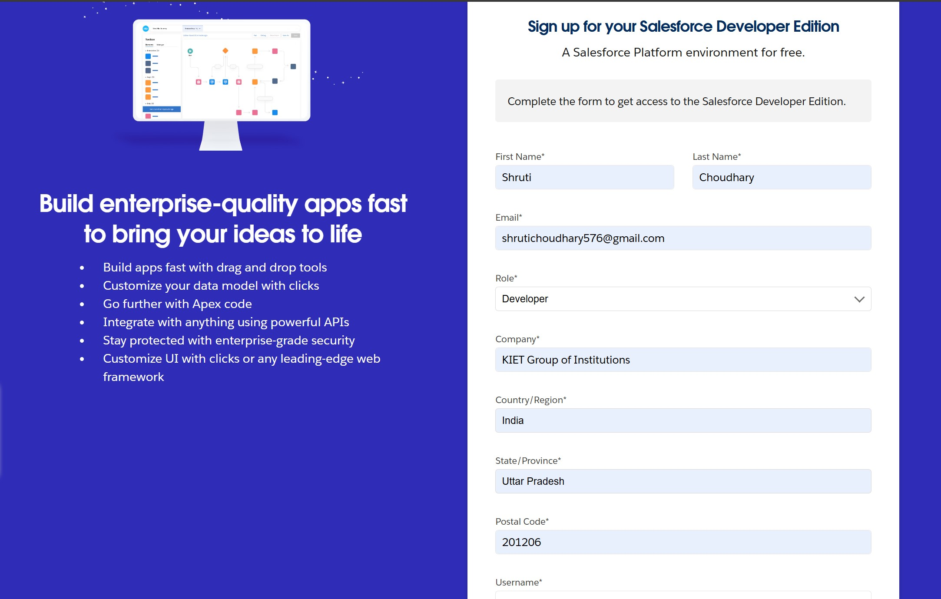

* **Account Activation**

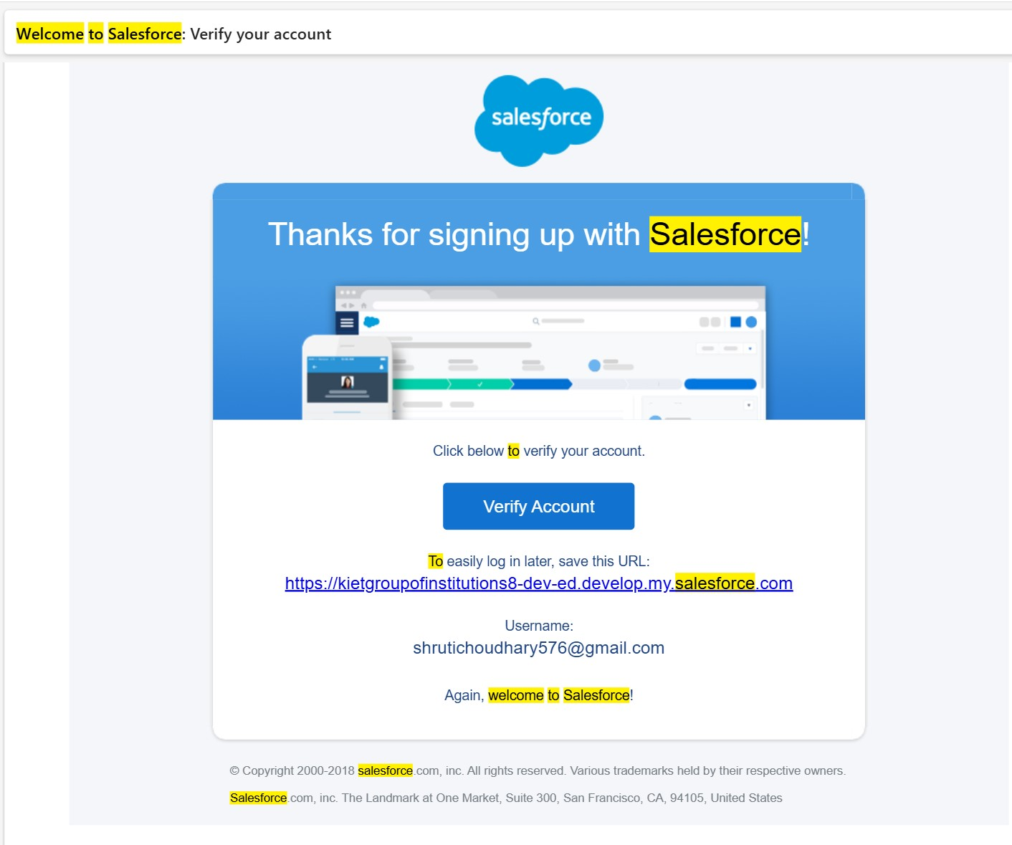

**Task 2. Object**

## ● Create Jewel Customer Object

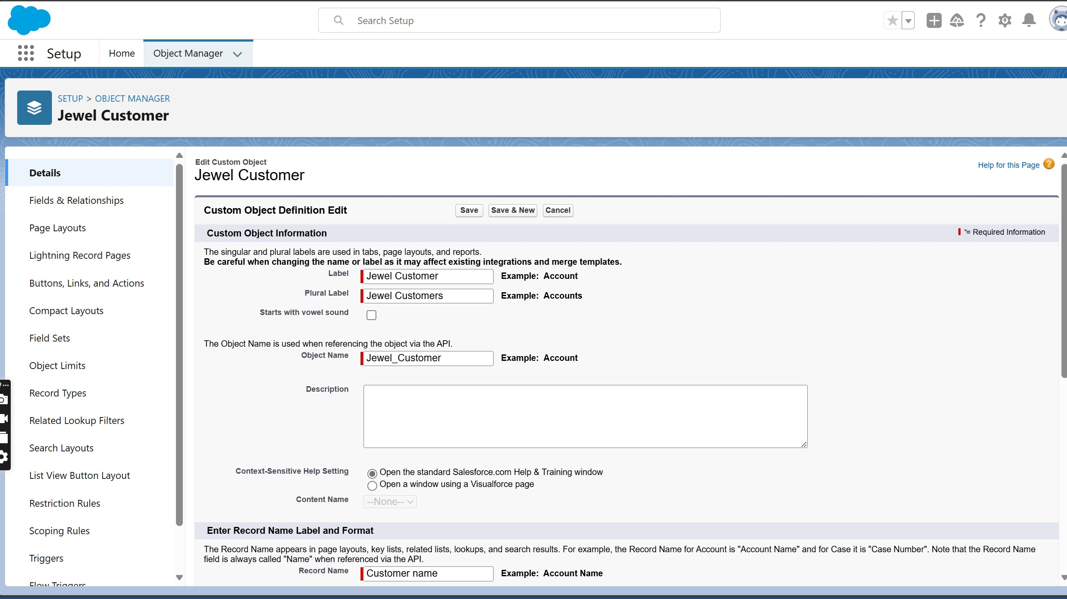

## ● Create Item Object

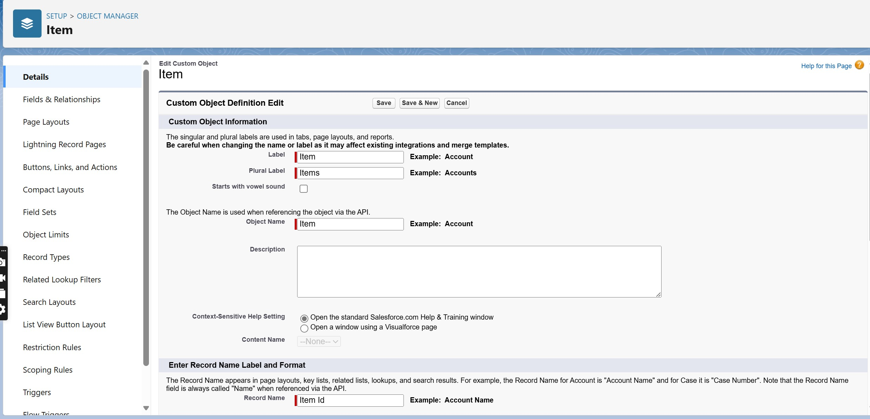



**Task 3. Tabs**

## ● Creating a Custom Tab

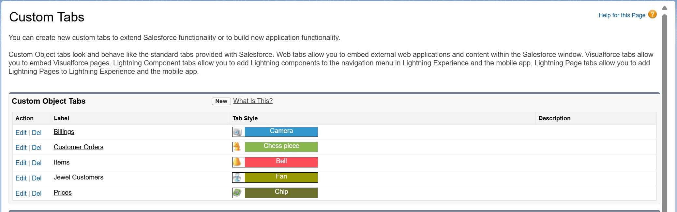

### Task 4. The Lightning App

● **Creating a Lightning App**

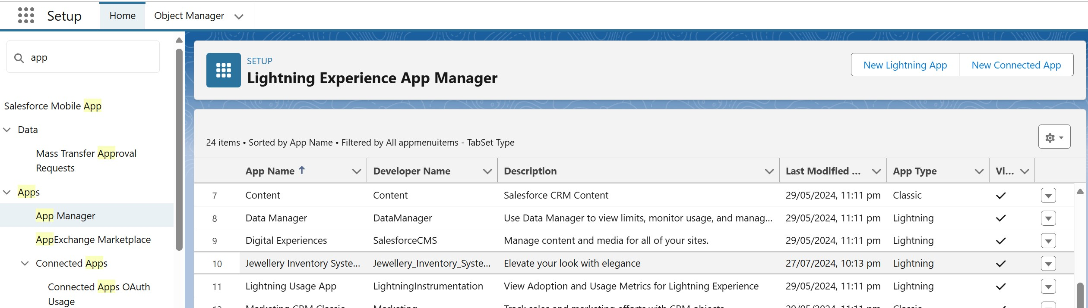

### Task 5. Fields

* **Creating a Lookup relationship**

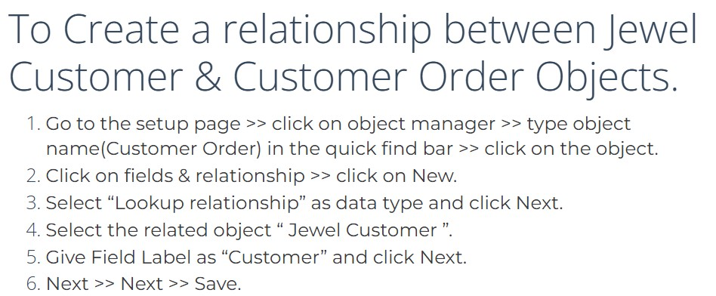

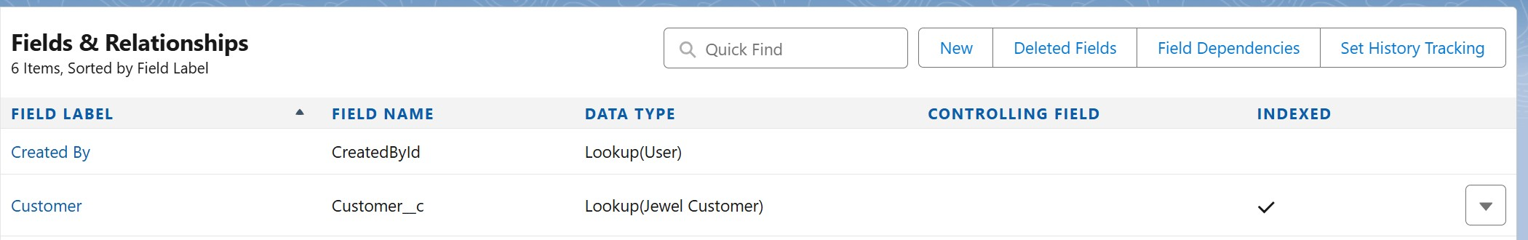

* **Creating a Master Detail Relationship**

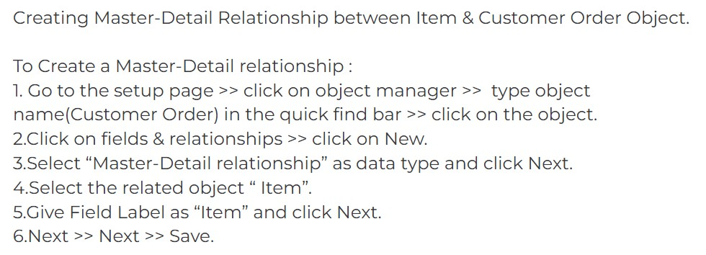

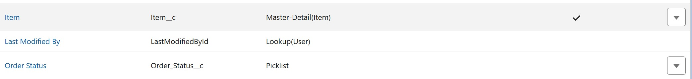

## ● Creating Fields in Jewel Customer Object

1. **City**

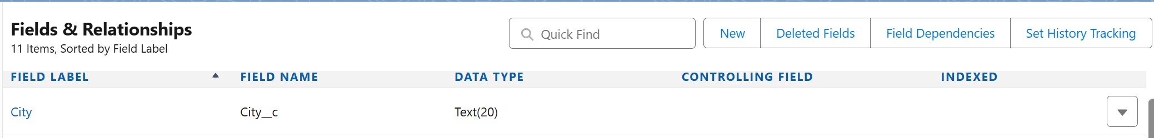

1. **Phone**



1. **Email**



1. **Order Status**

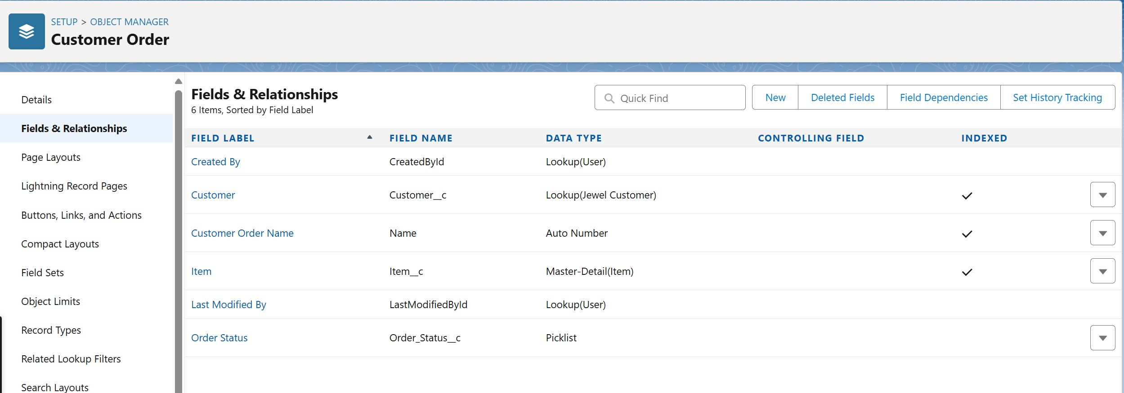

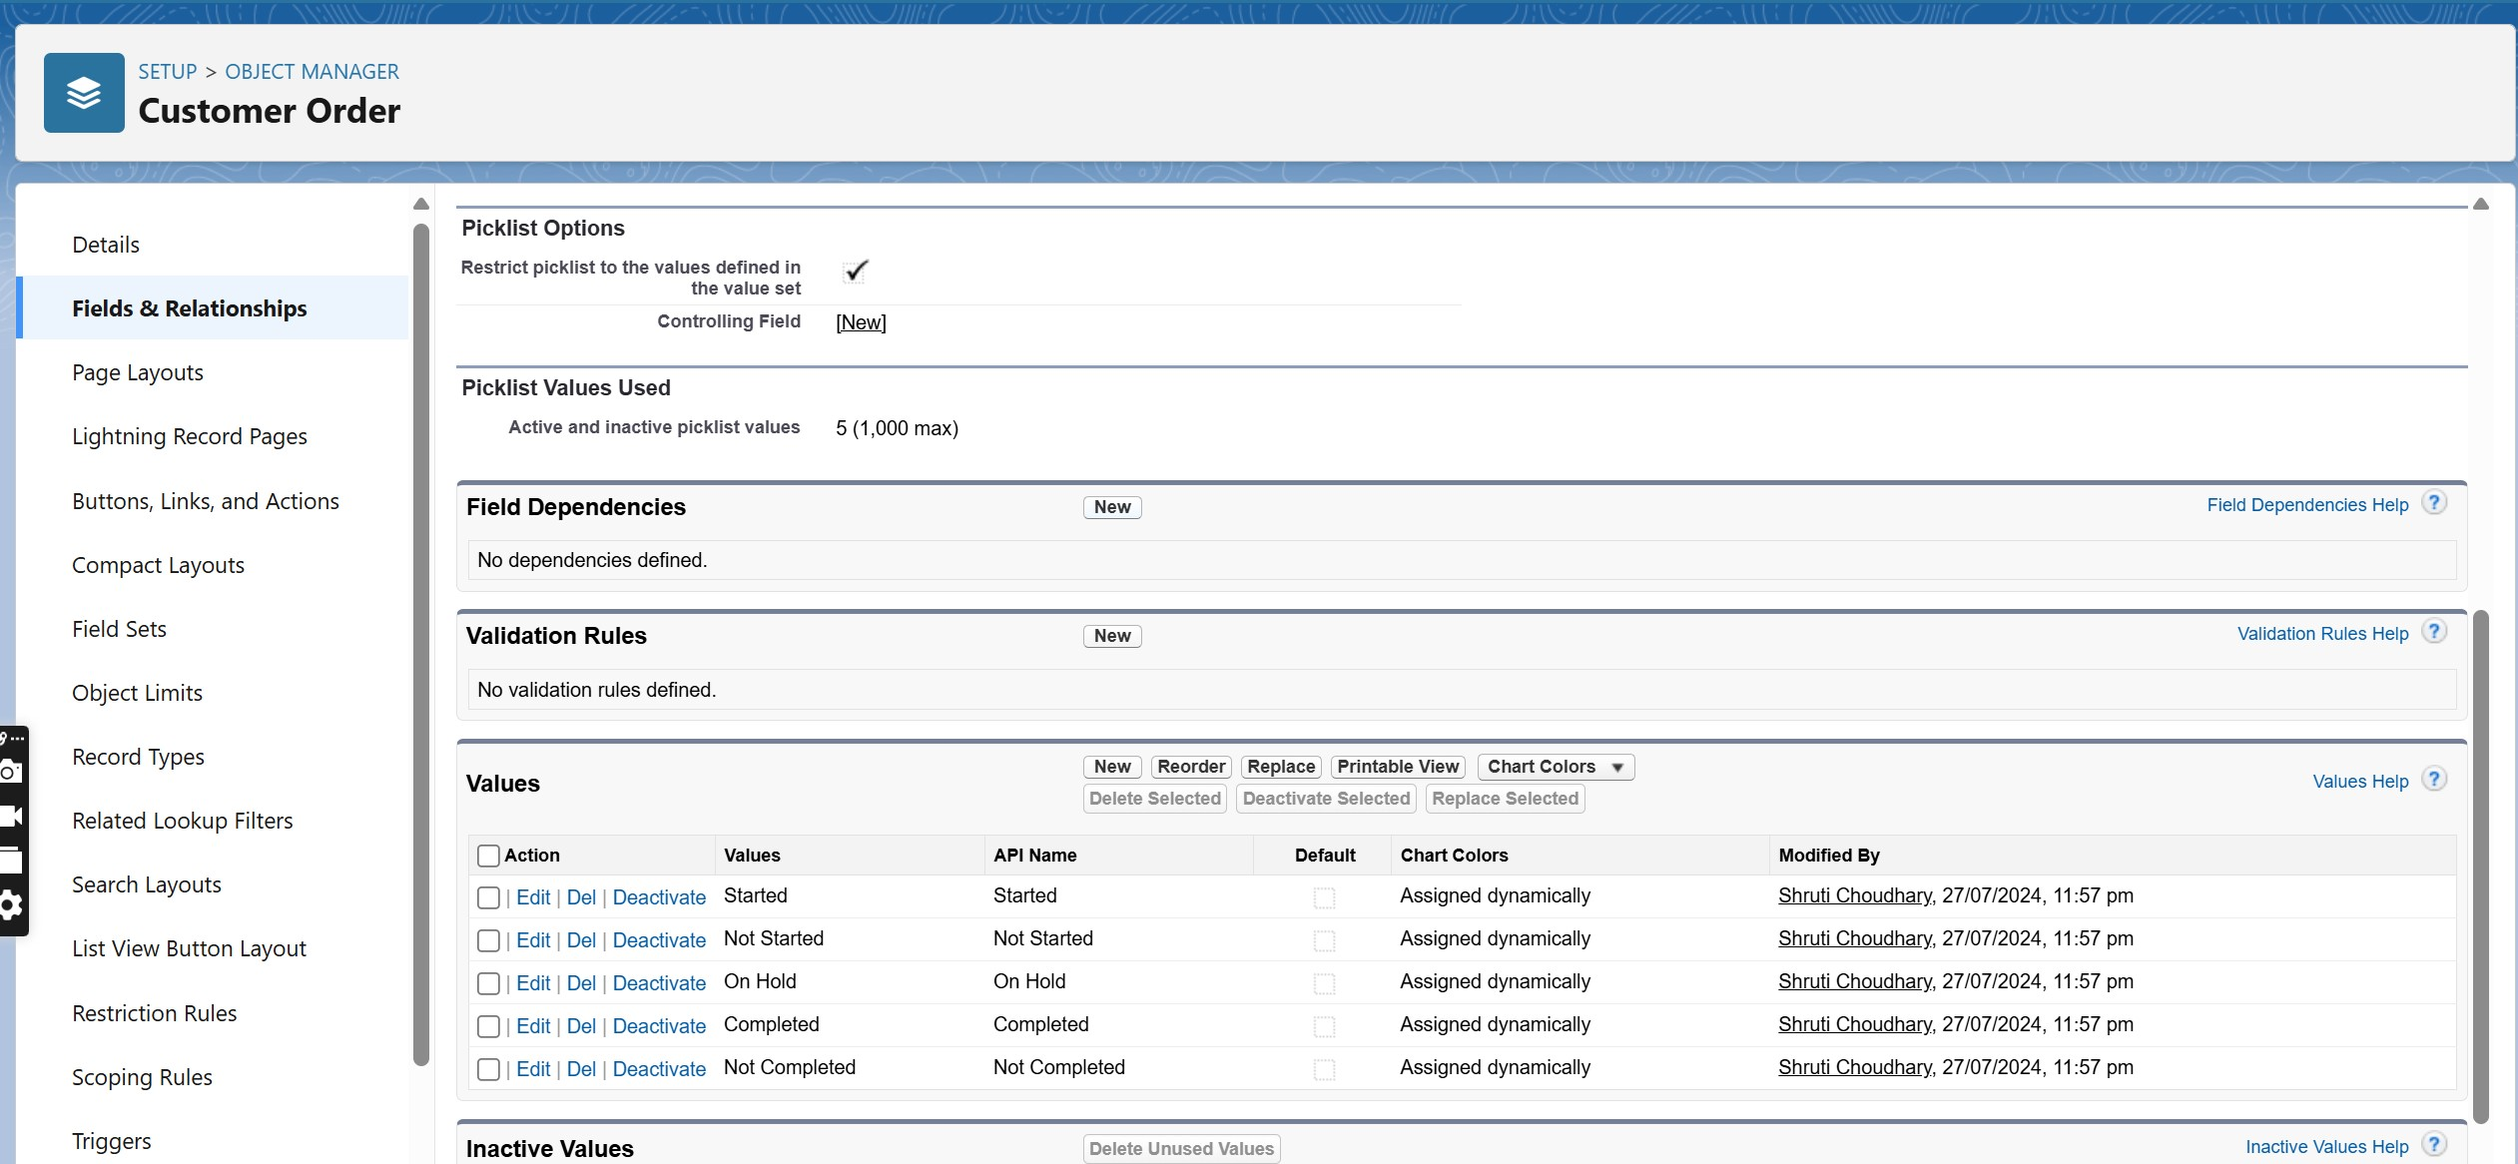

1. **More fields**

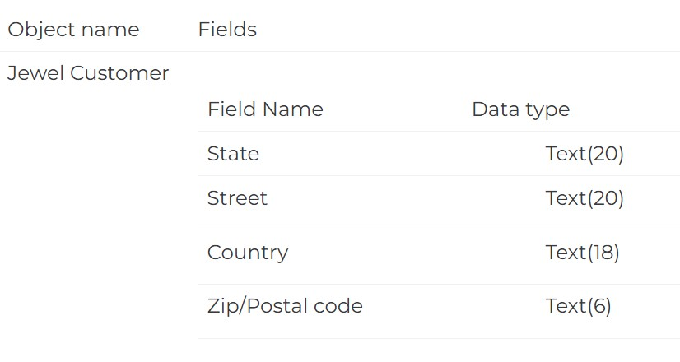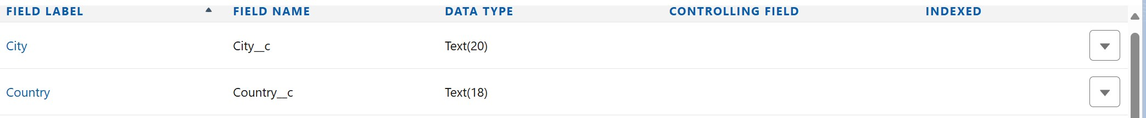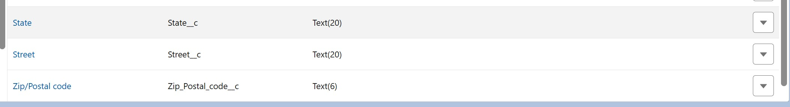

## ● Creating Fields in Item Object

1. Number Field



1. Picklist Field

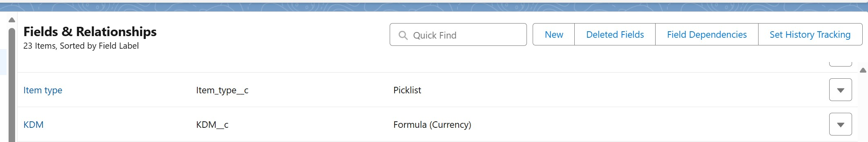

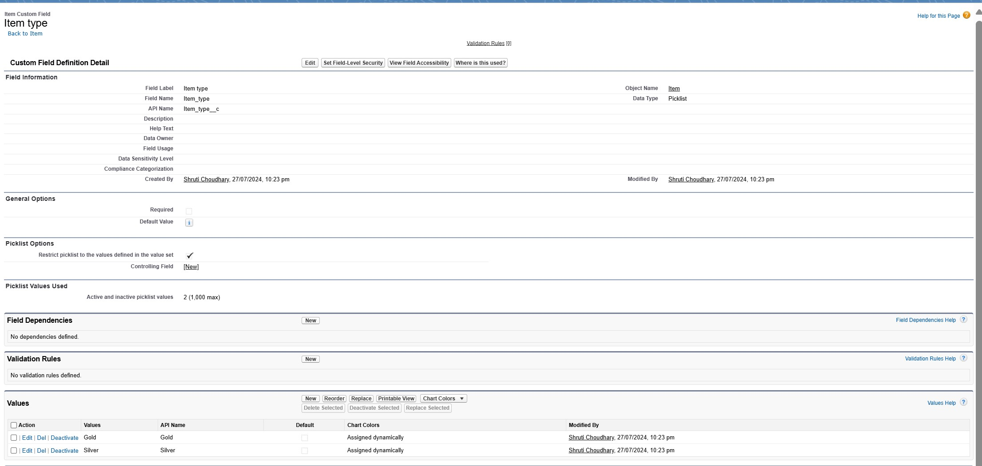

1. Formula Field



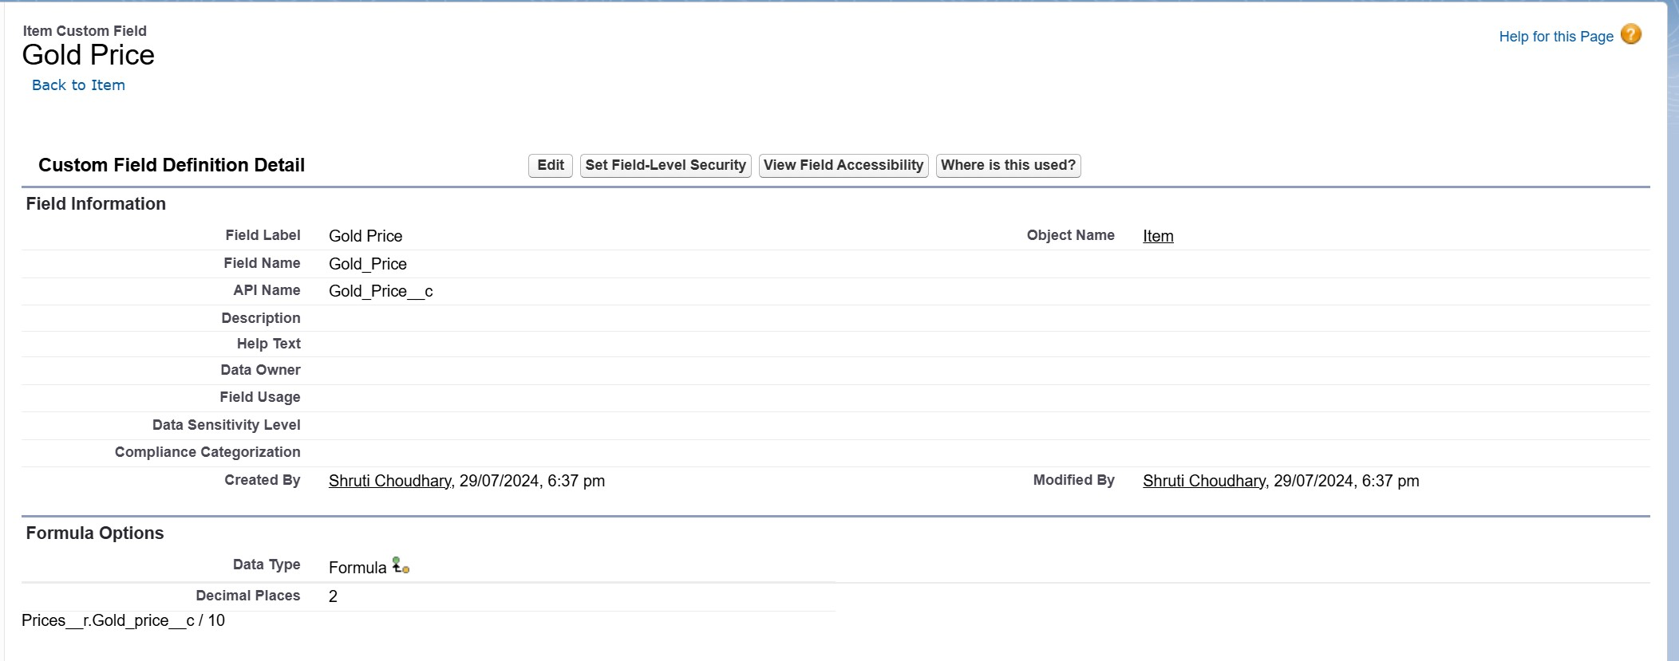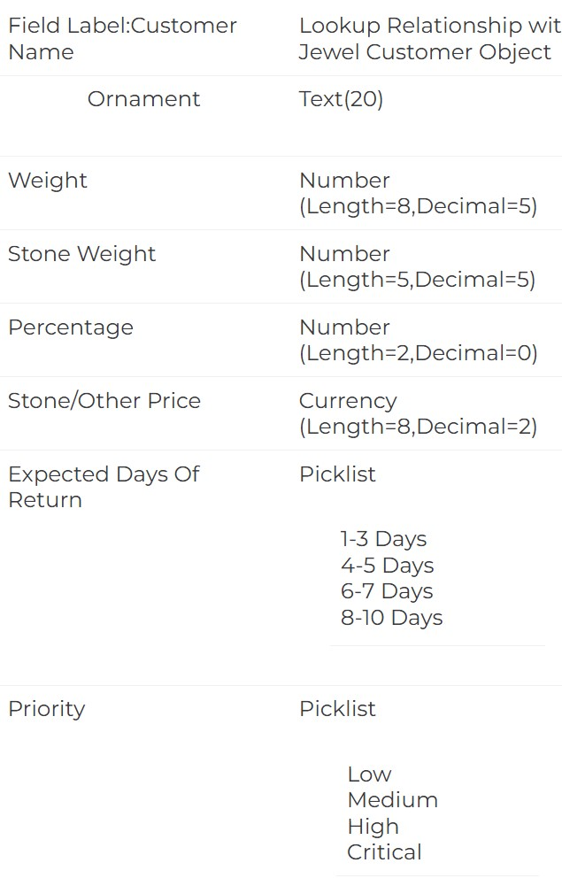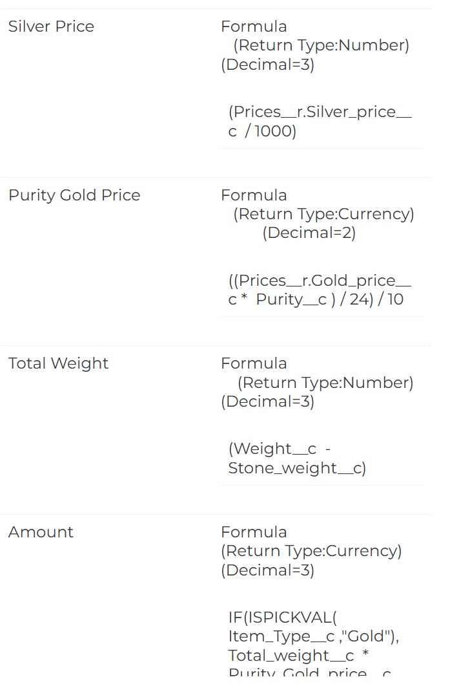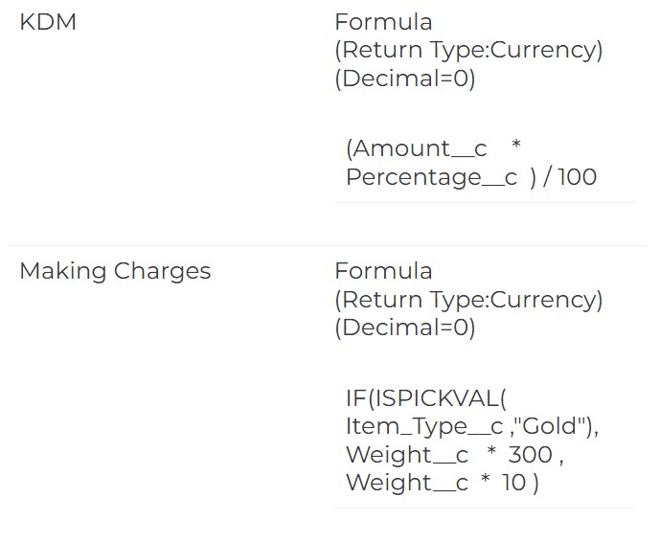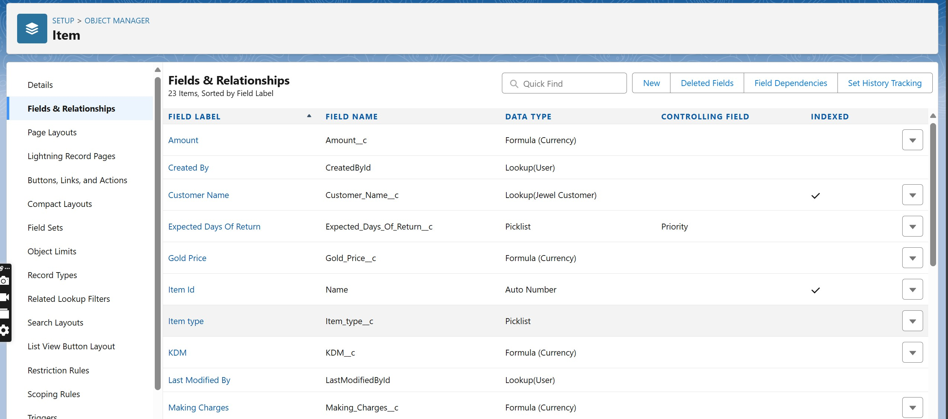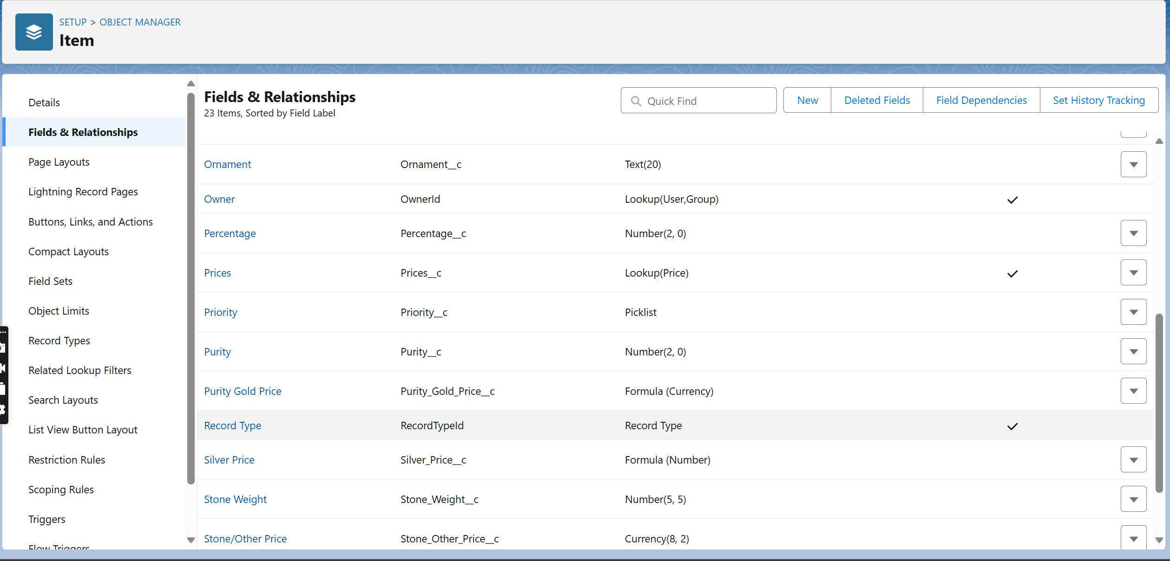

## ● Creating Field in Price Object

1. Currency Field

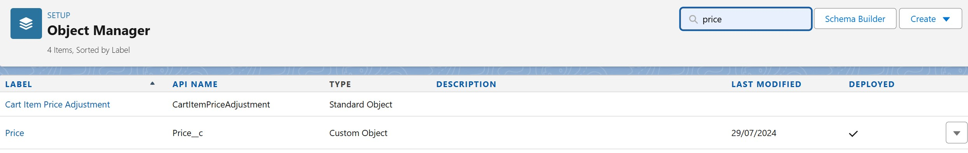

1. Silver Price

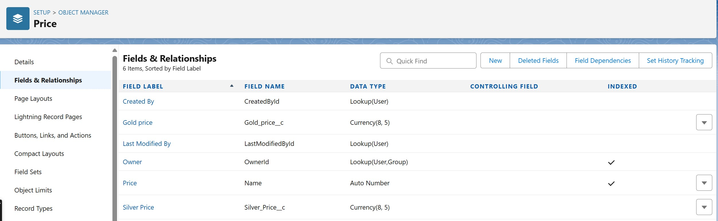

## ● Creating Field in Billing Object

-------Task to be done

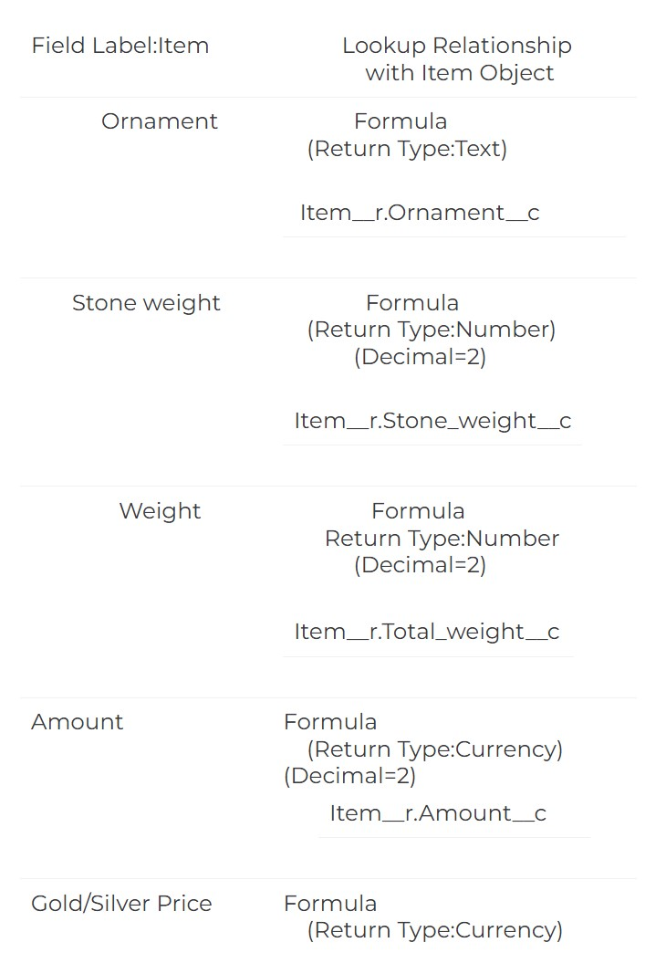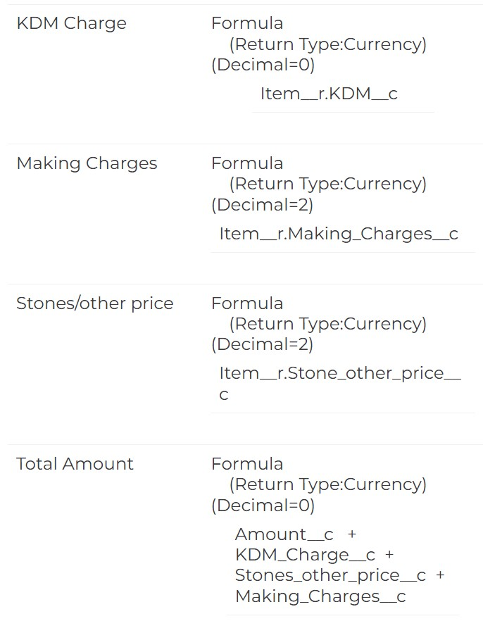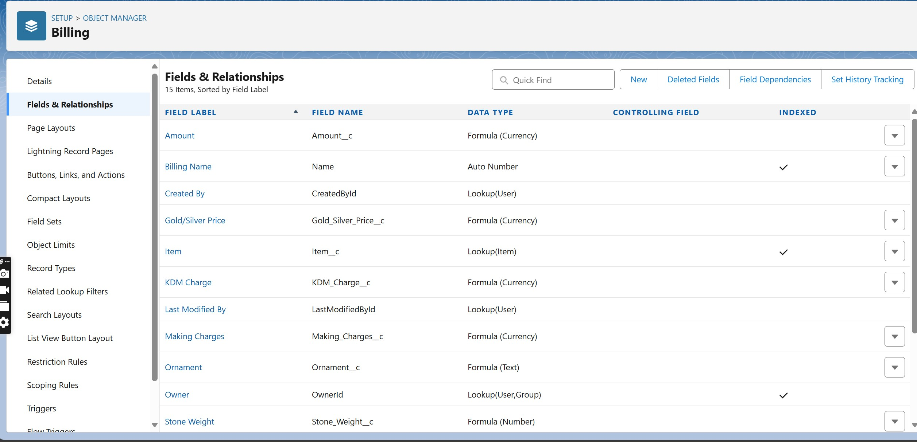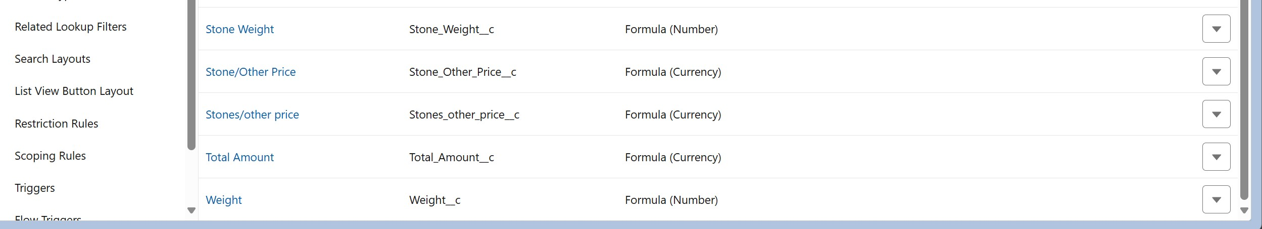

## ● Schema Builder

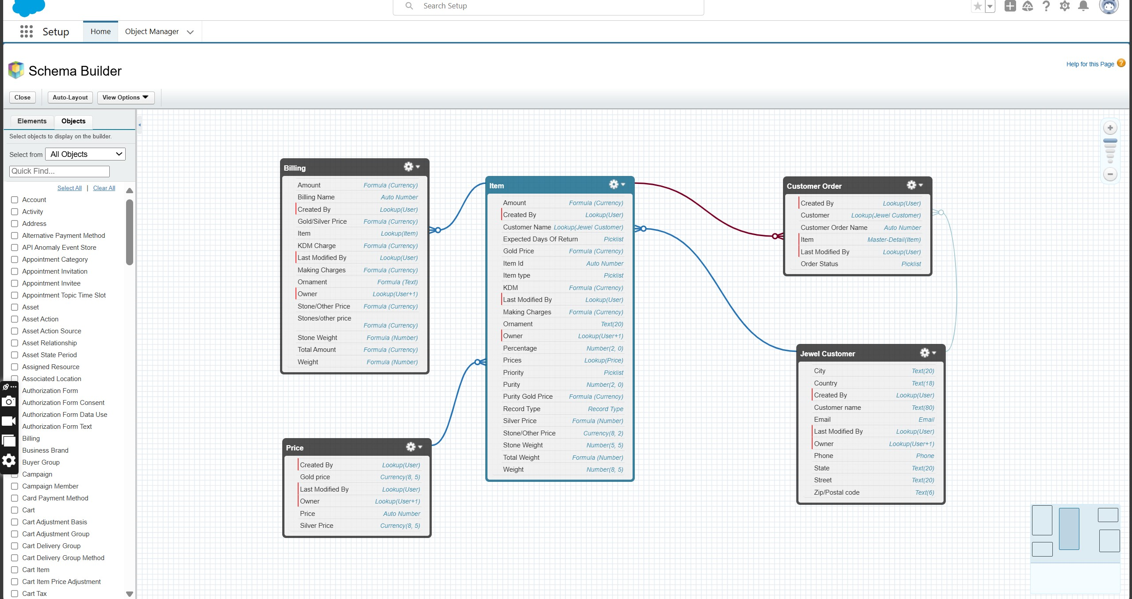

## ● Creating the Field dependencies

Step 1

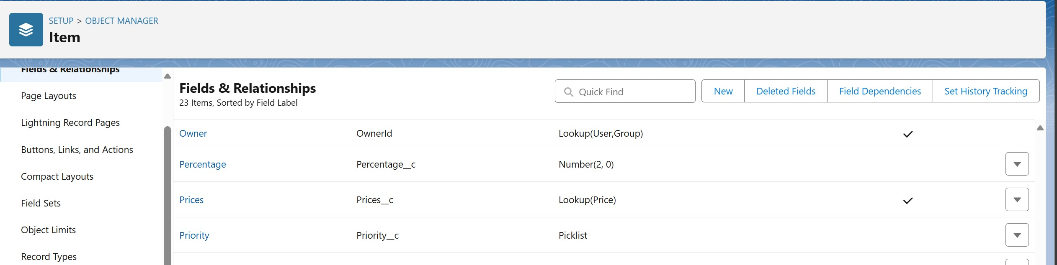

Step 2

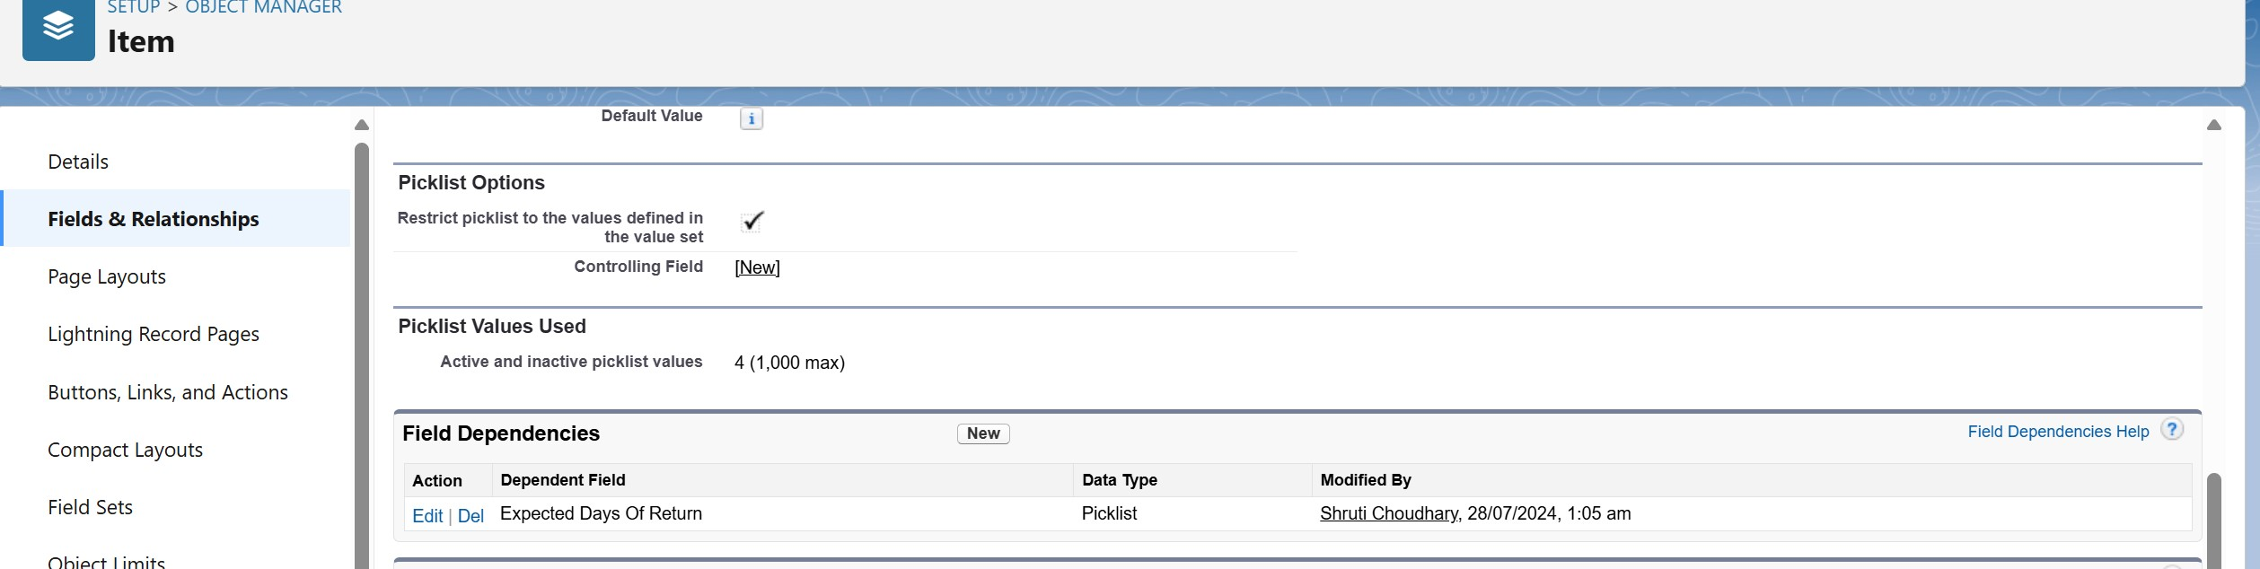

## ● Creating the Validation rules

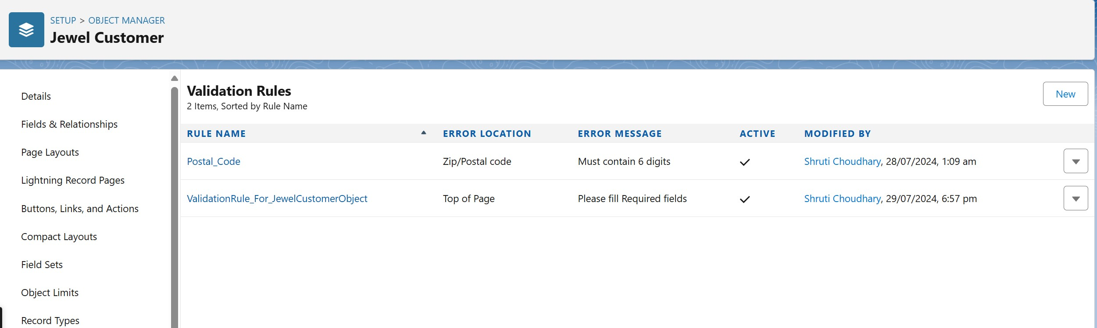

**Task 6. Profiles**

* **Creating Goldsmith Profile**

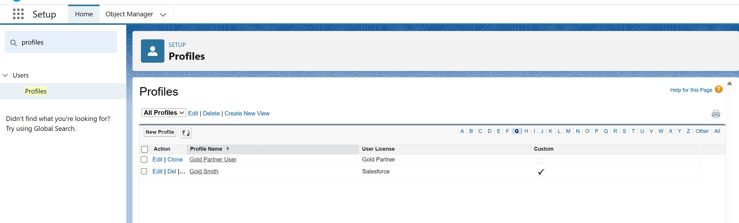

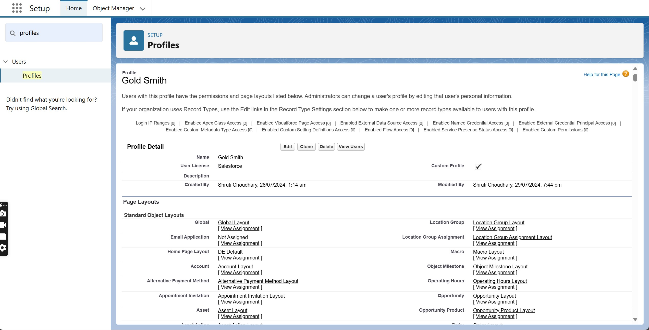

* **Creating Worker Profile**

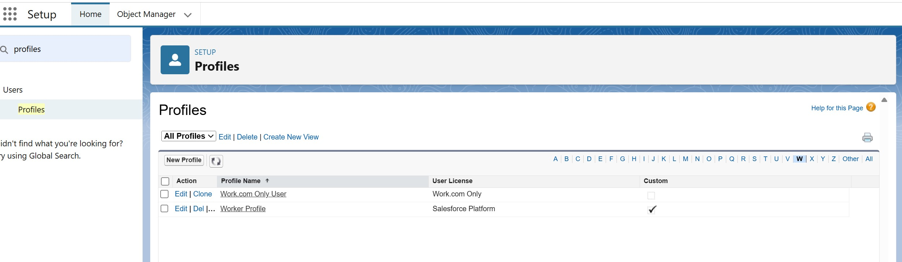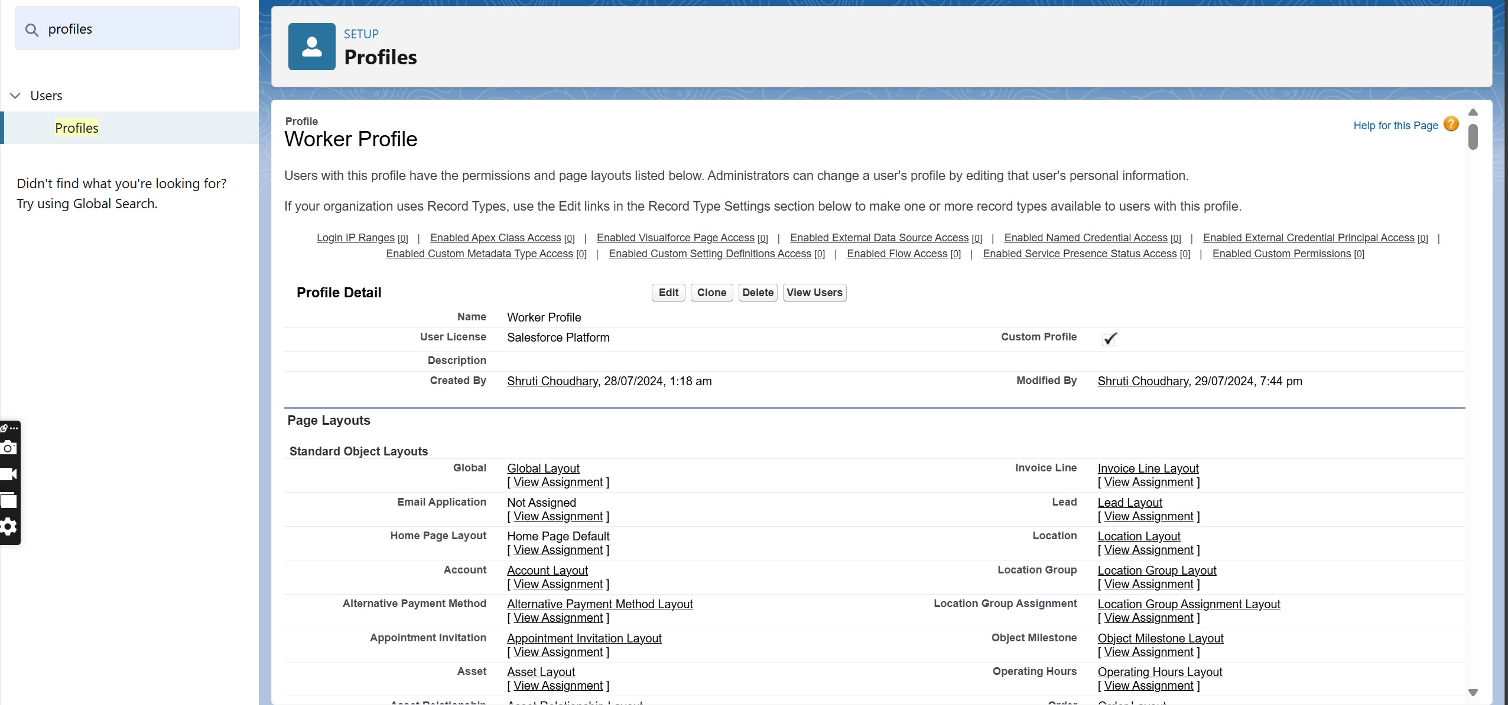

**Task 7. Roles**

* **Creating Goldsmith Role**

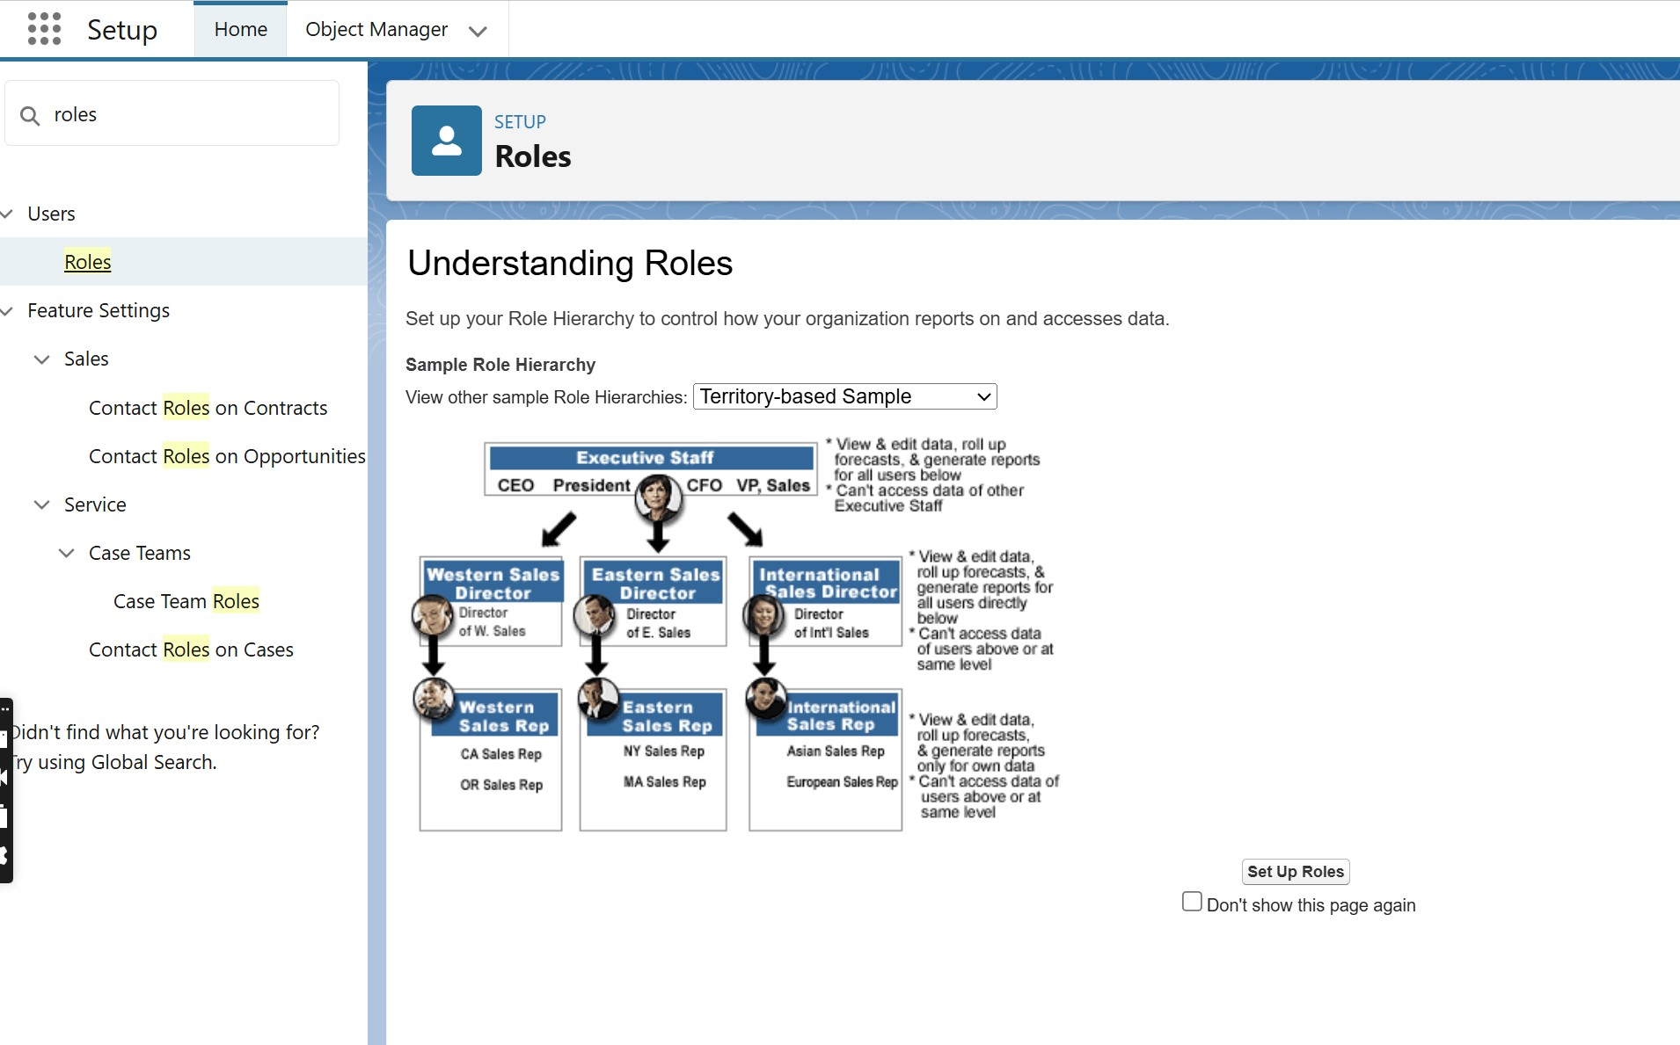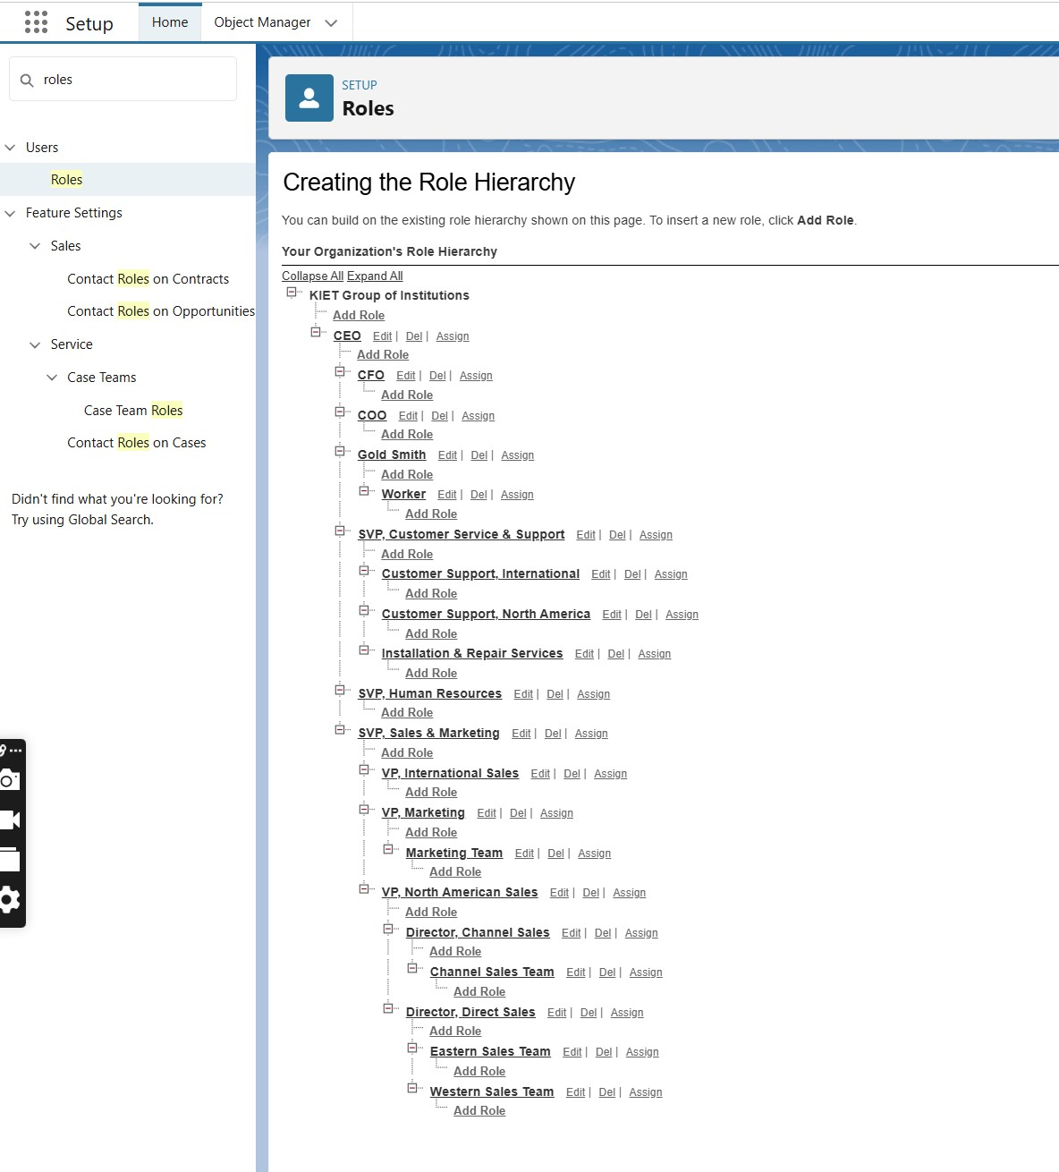

**Gold Smith Role**

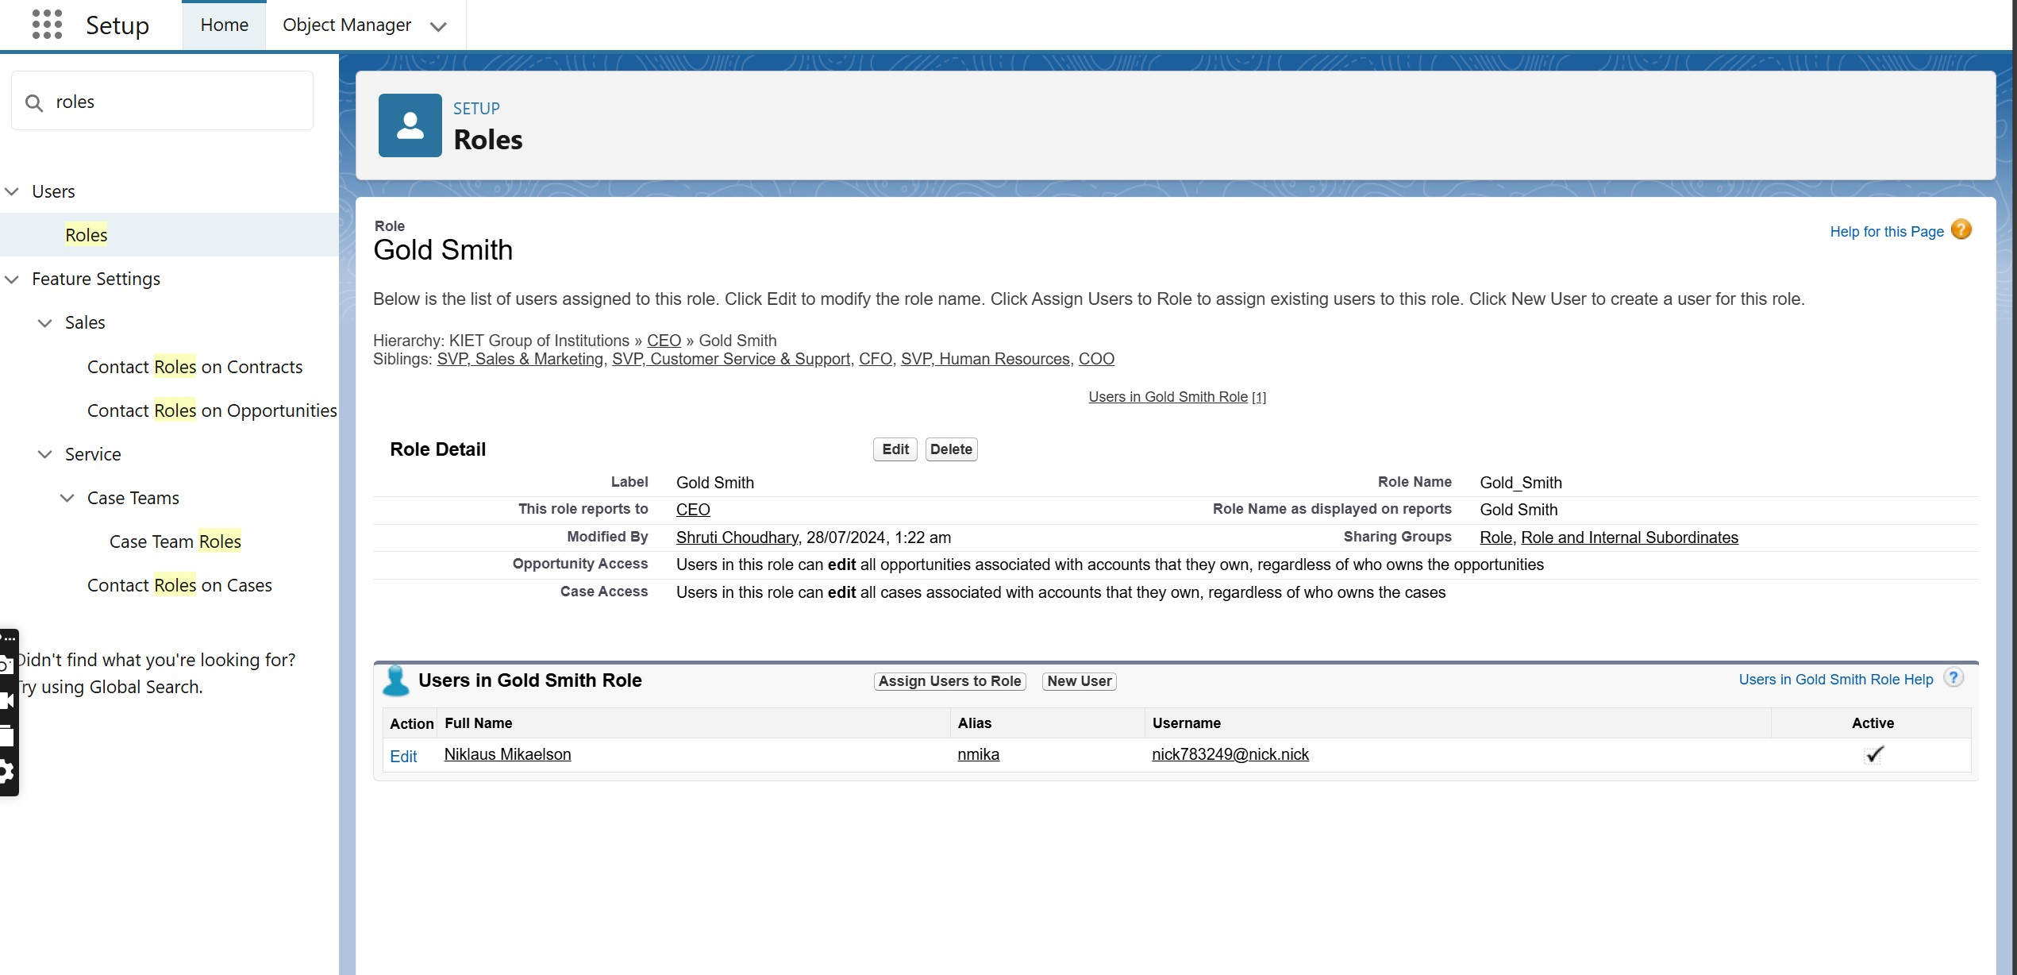

**Worker Role**

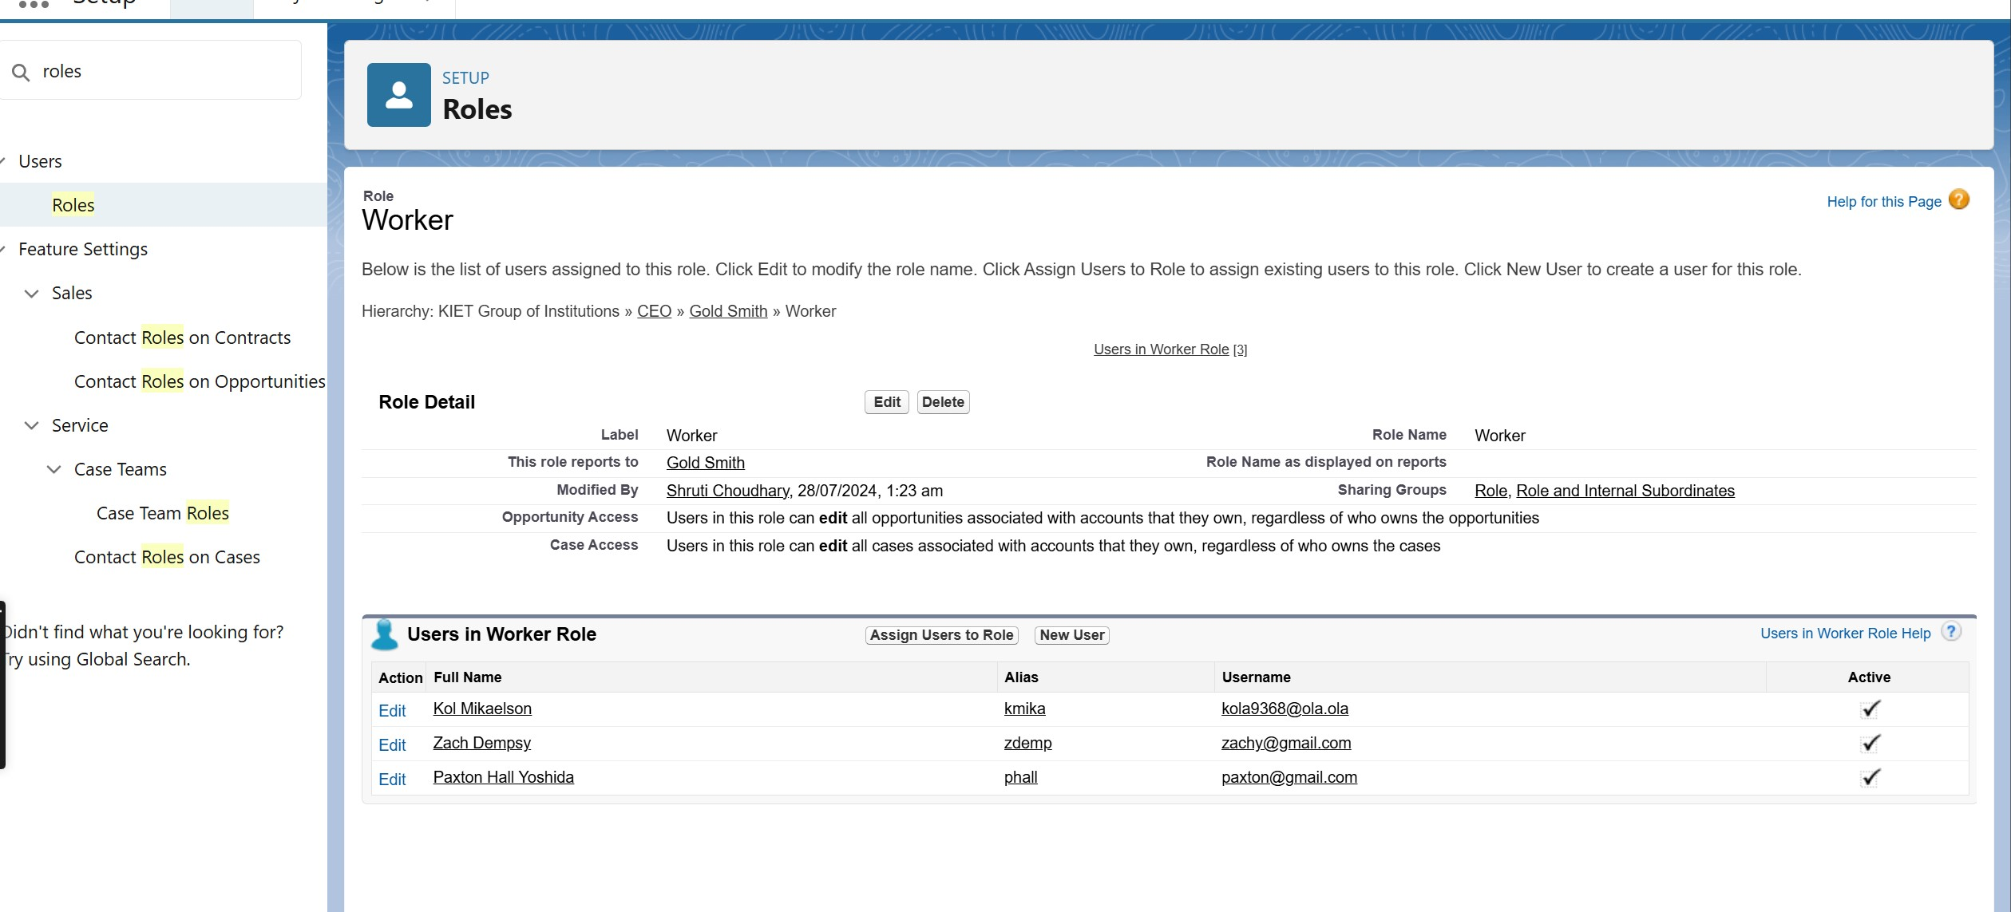

**Task 8. Users**

* **Create User**

**Task to do:**

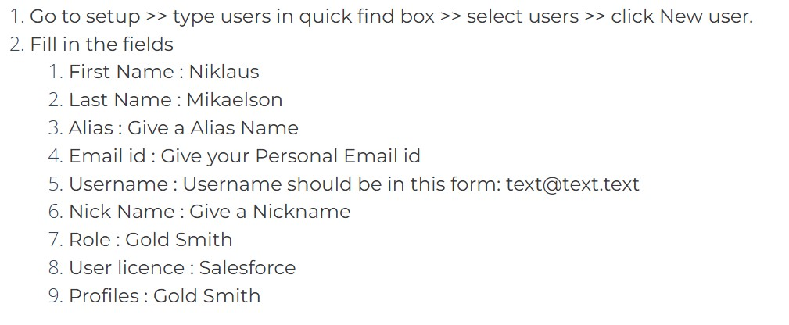

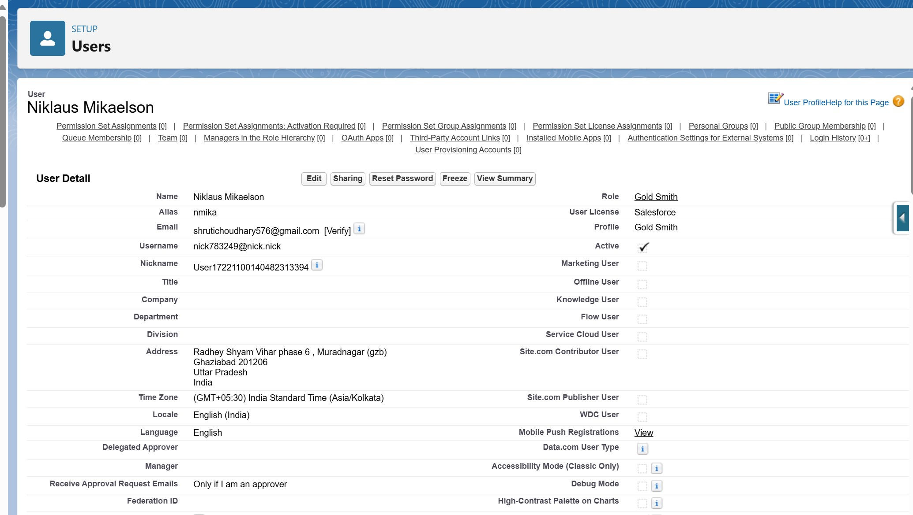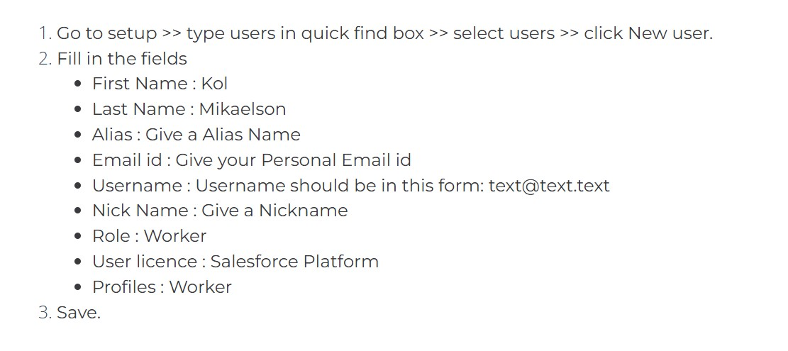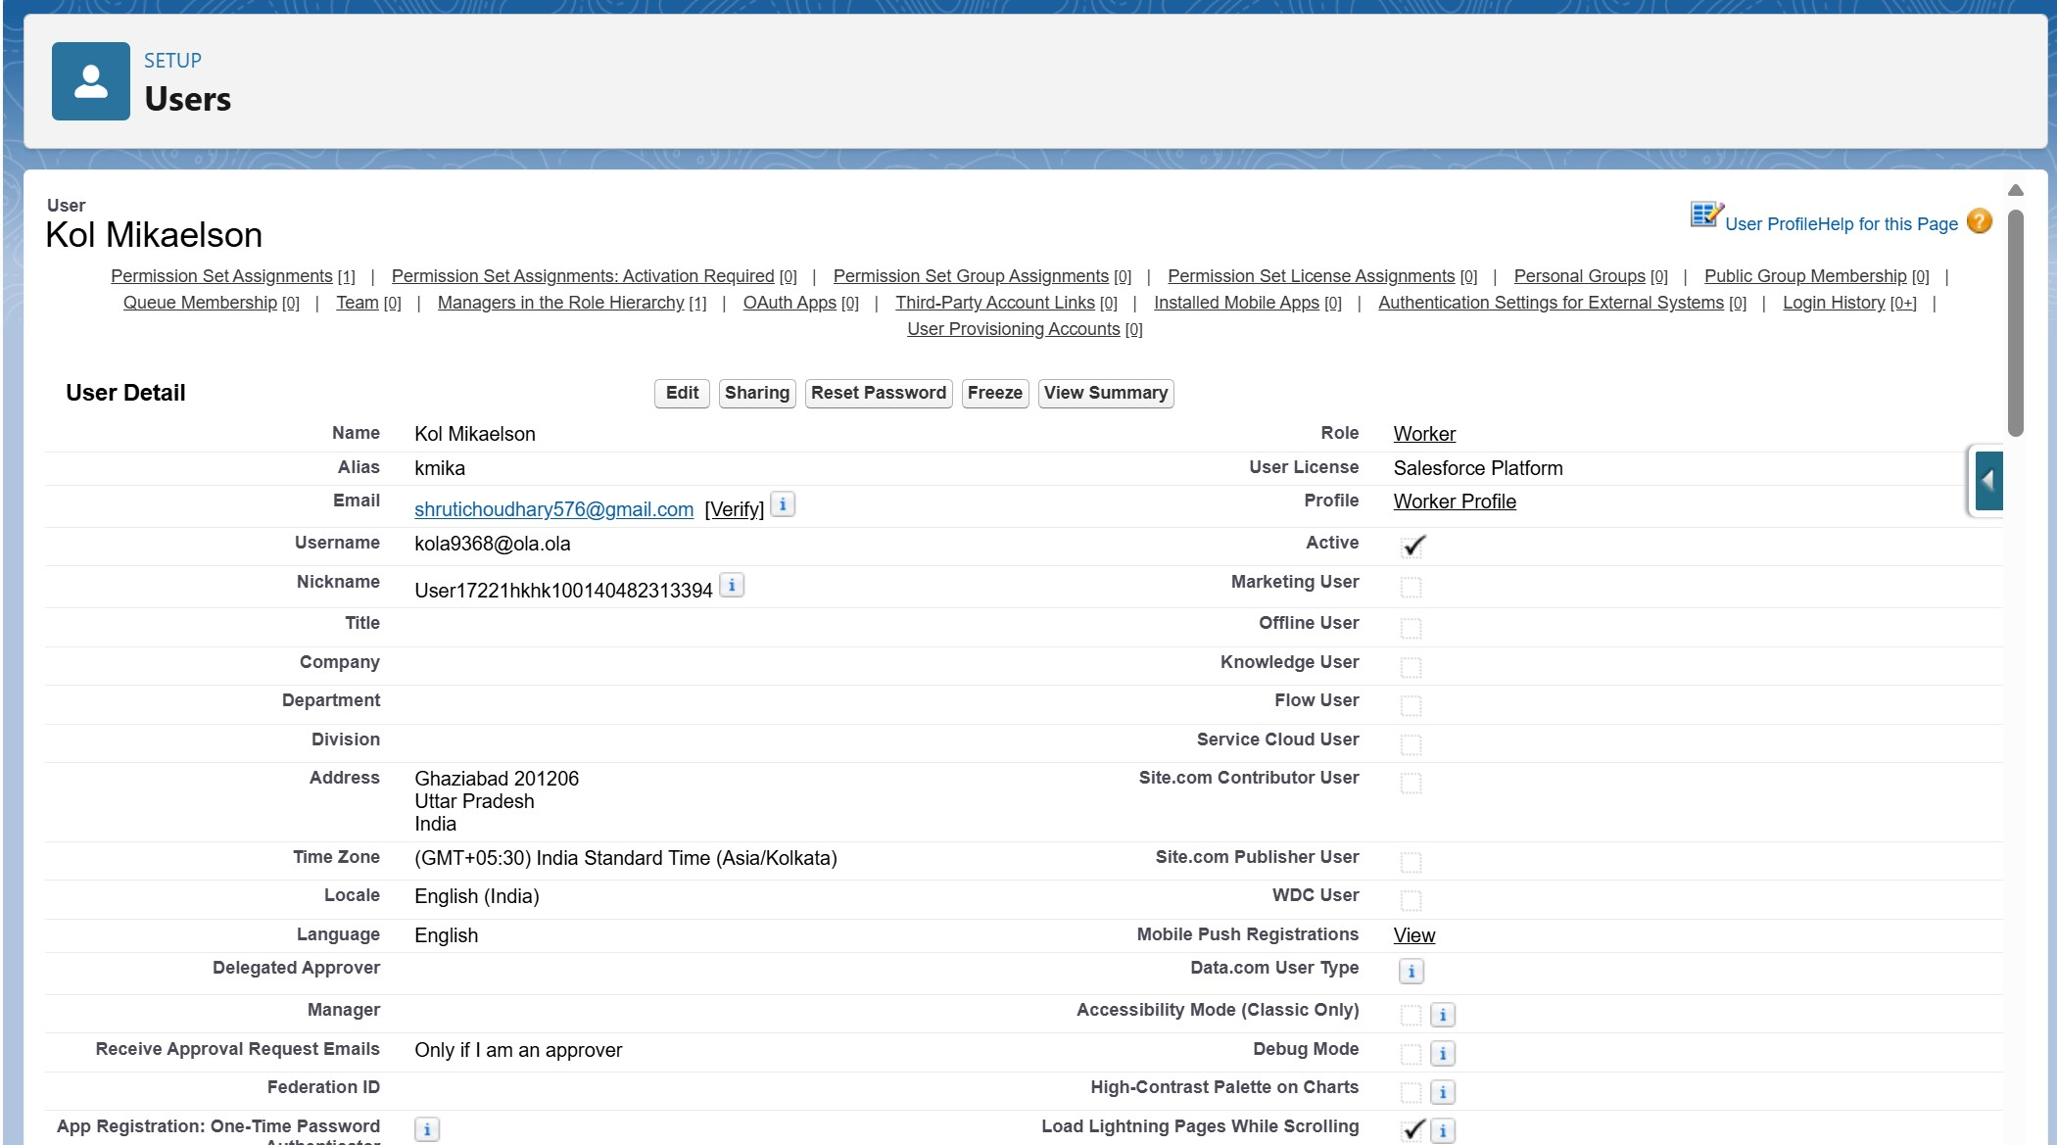

**Two more Users**

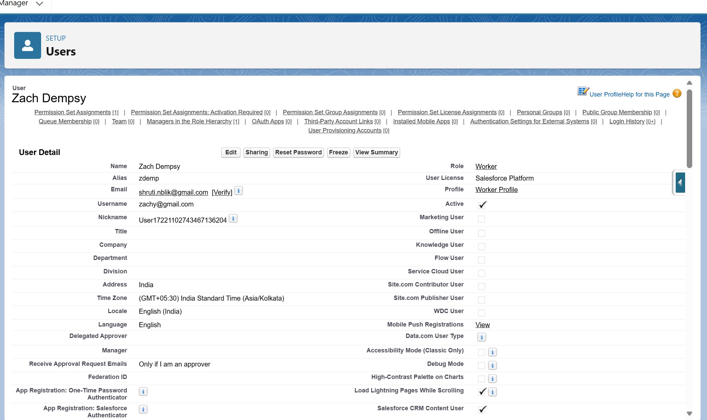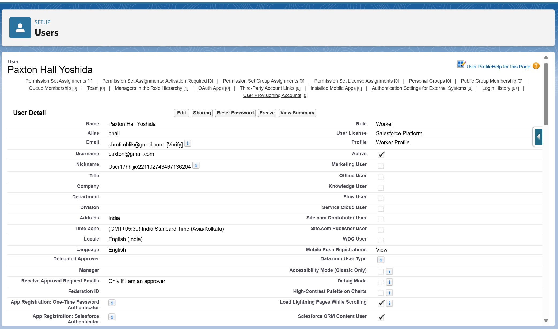

**Task 9. Page Layouts**

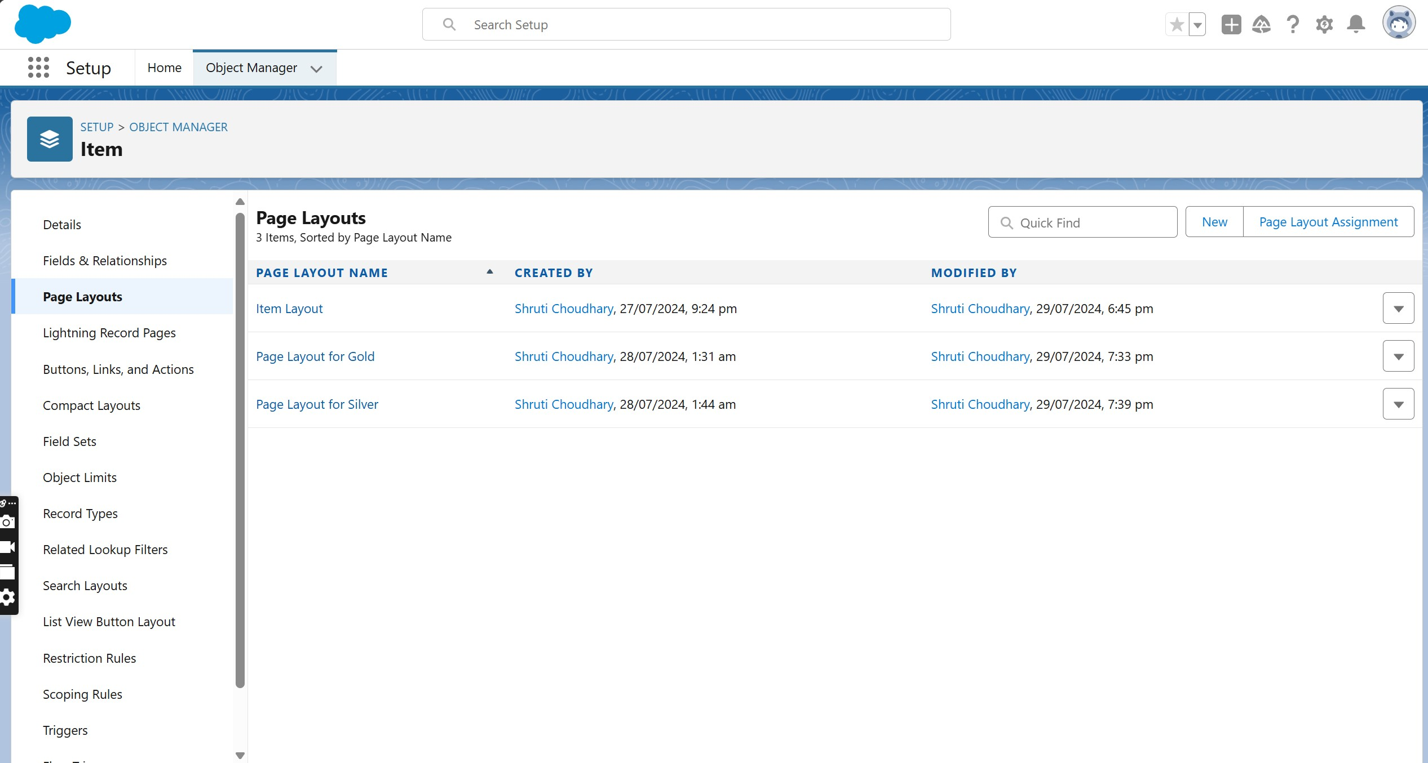

* **Create a Gold page layout**

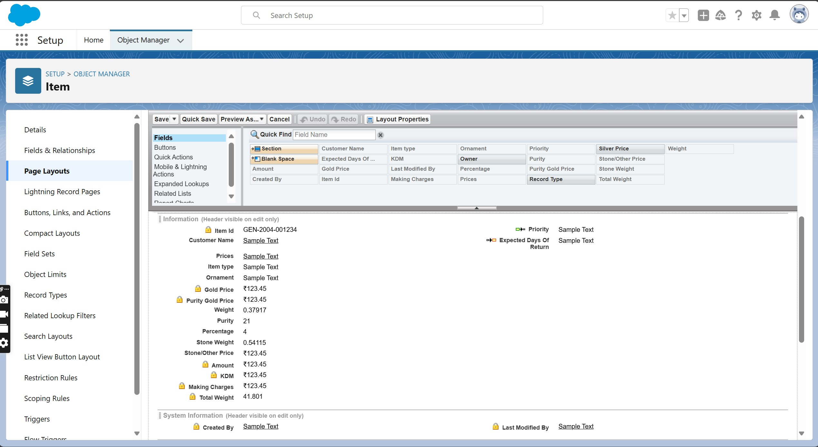

* **Create a Silver page layout**

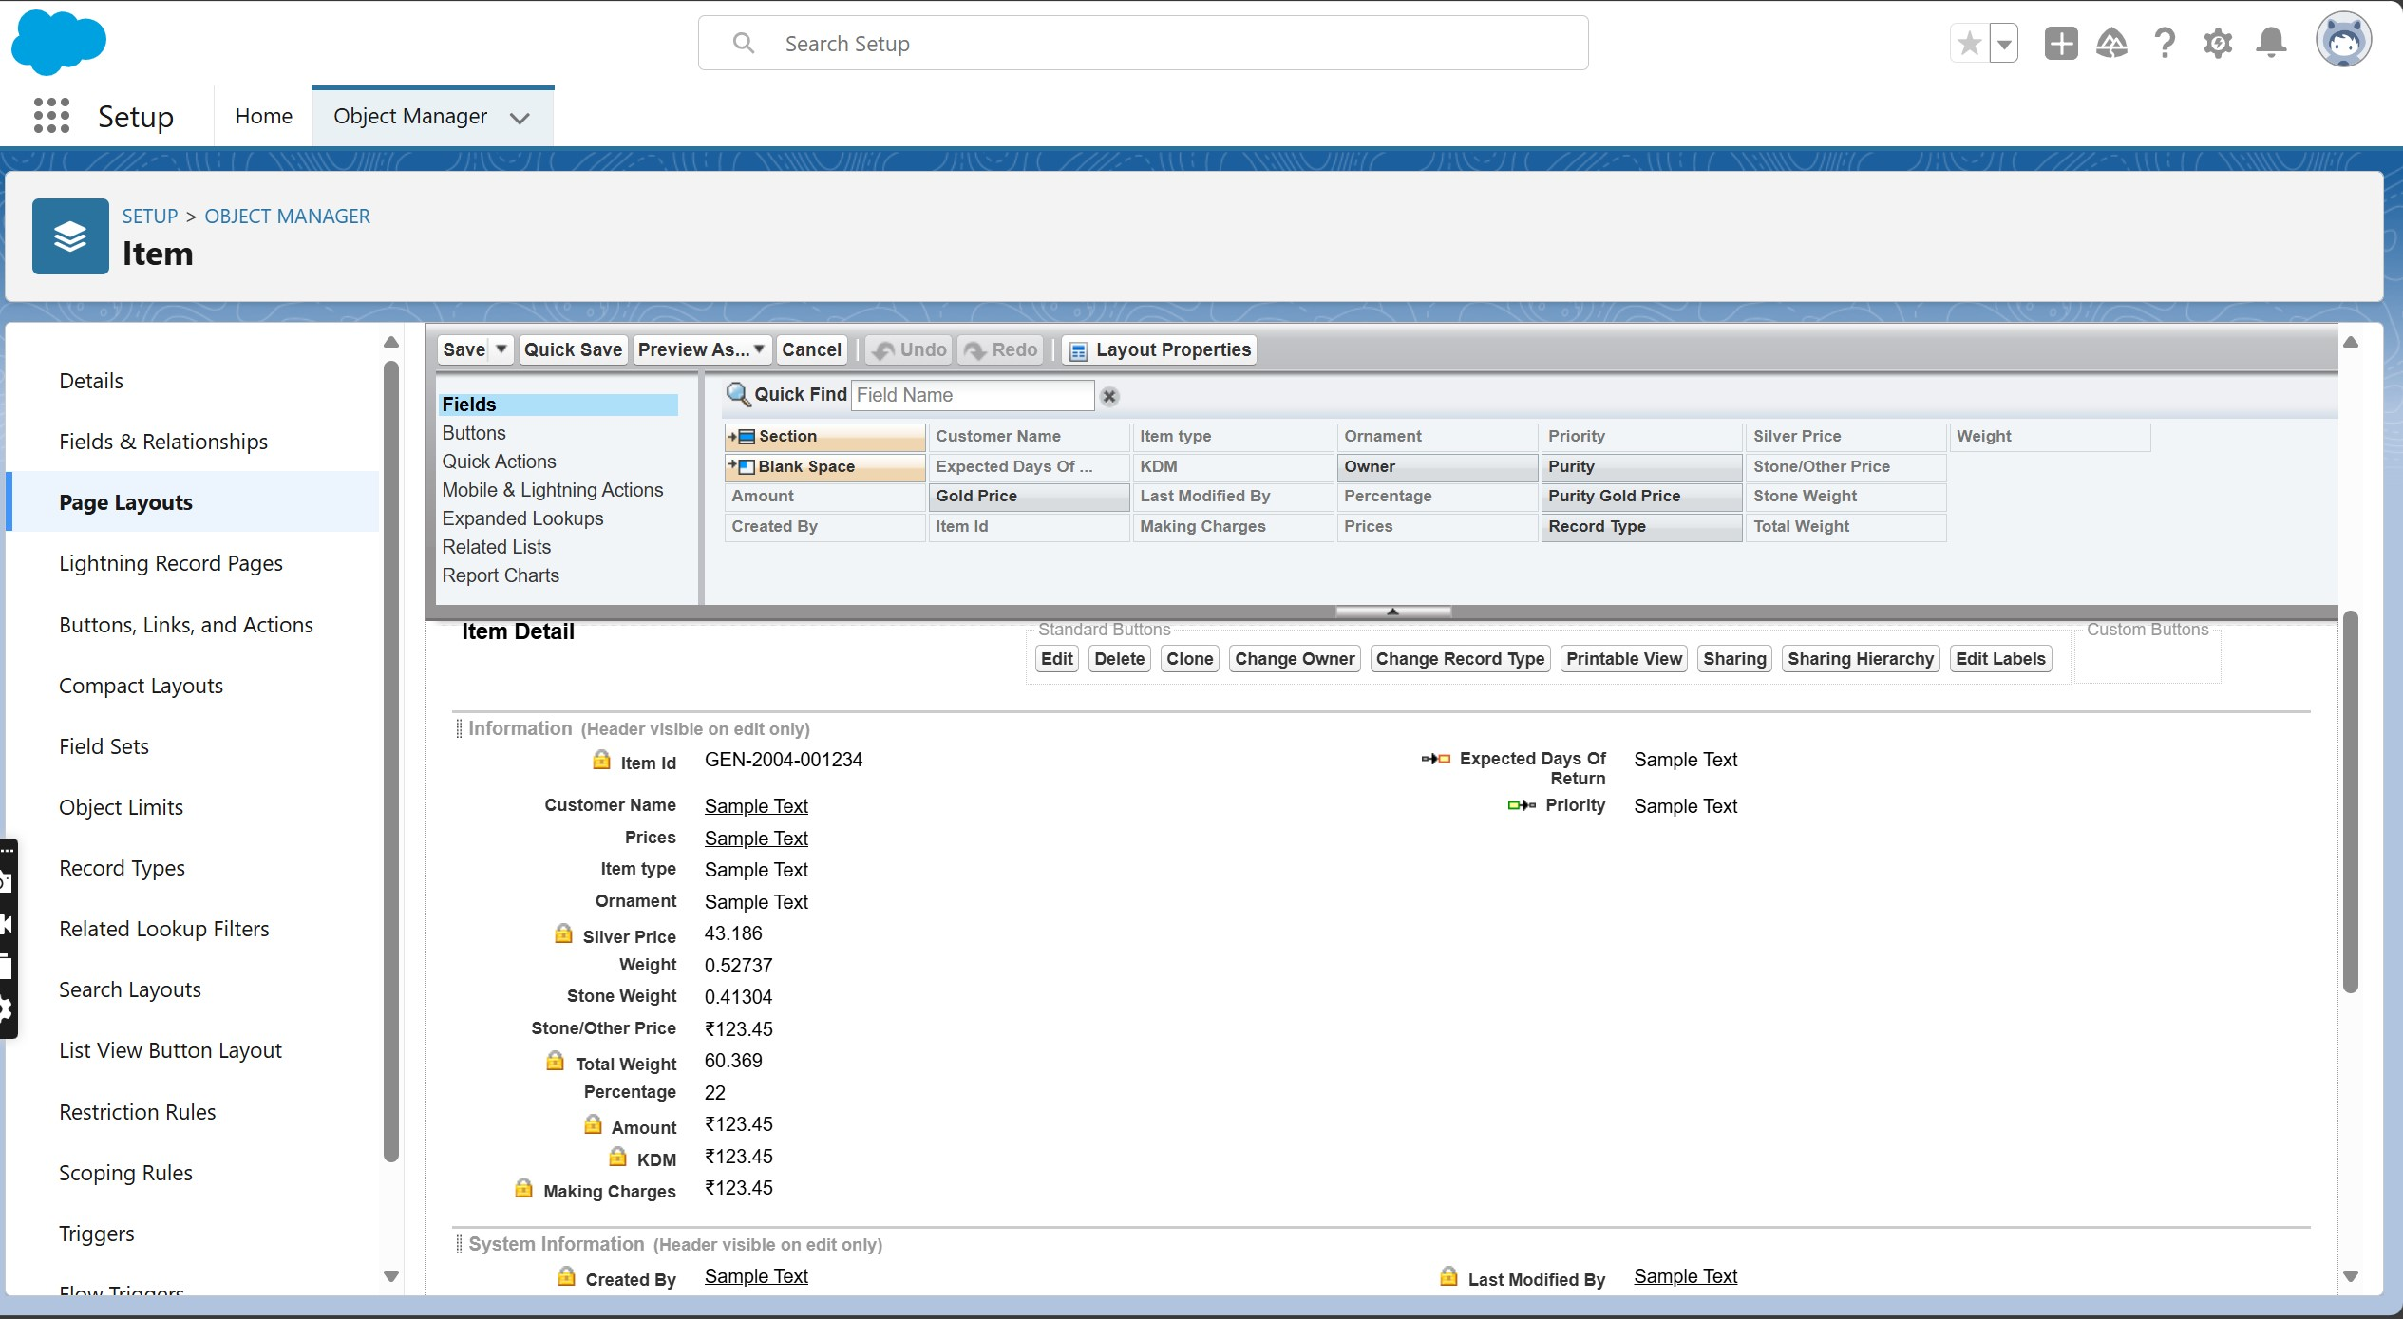

### Task 10. Record Types

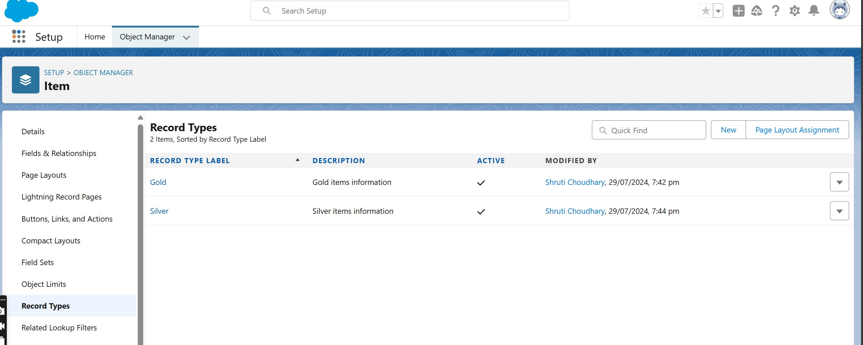

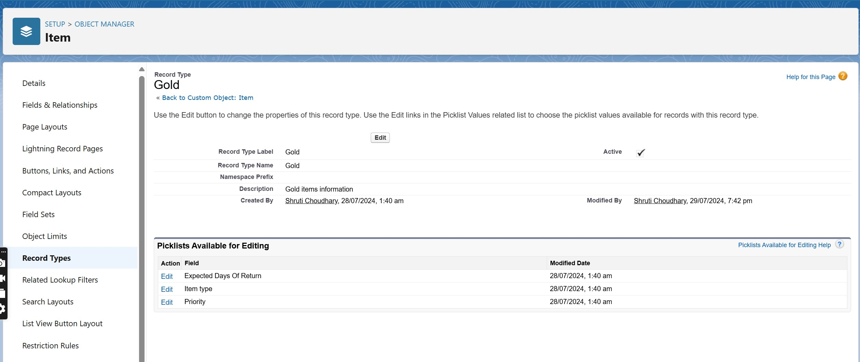

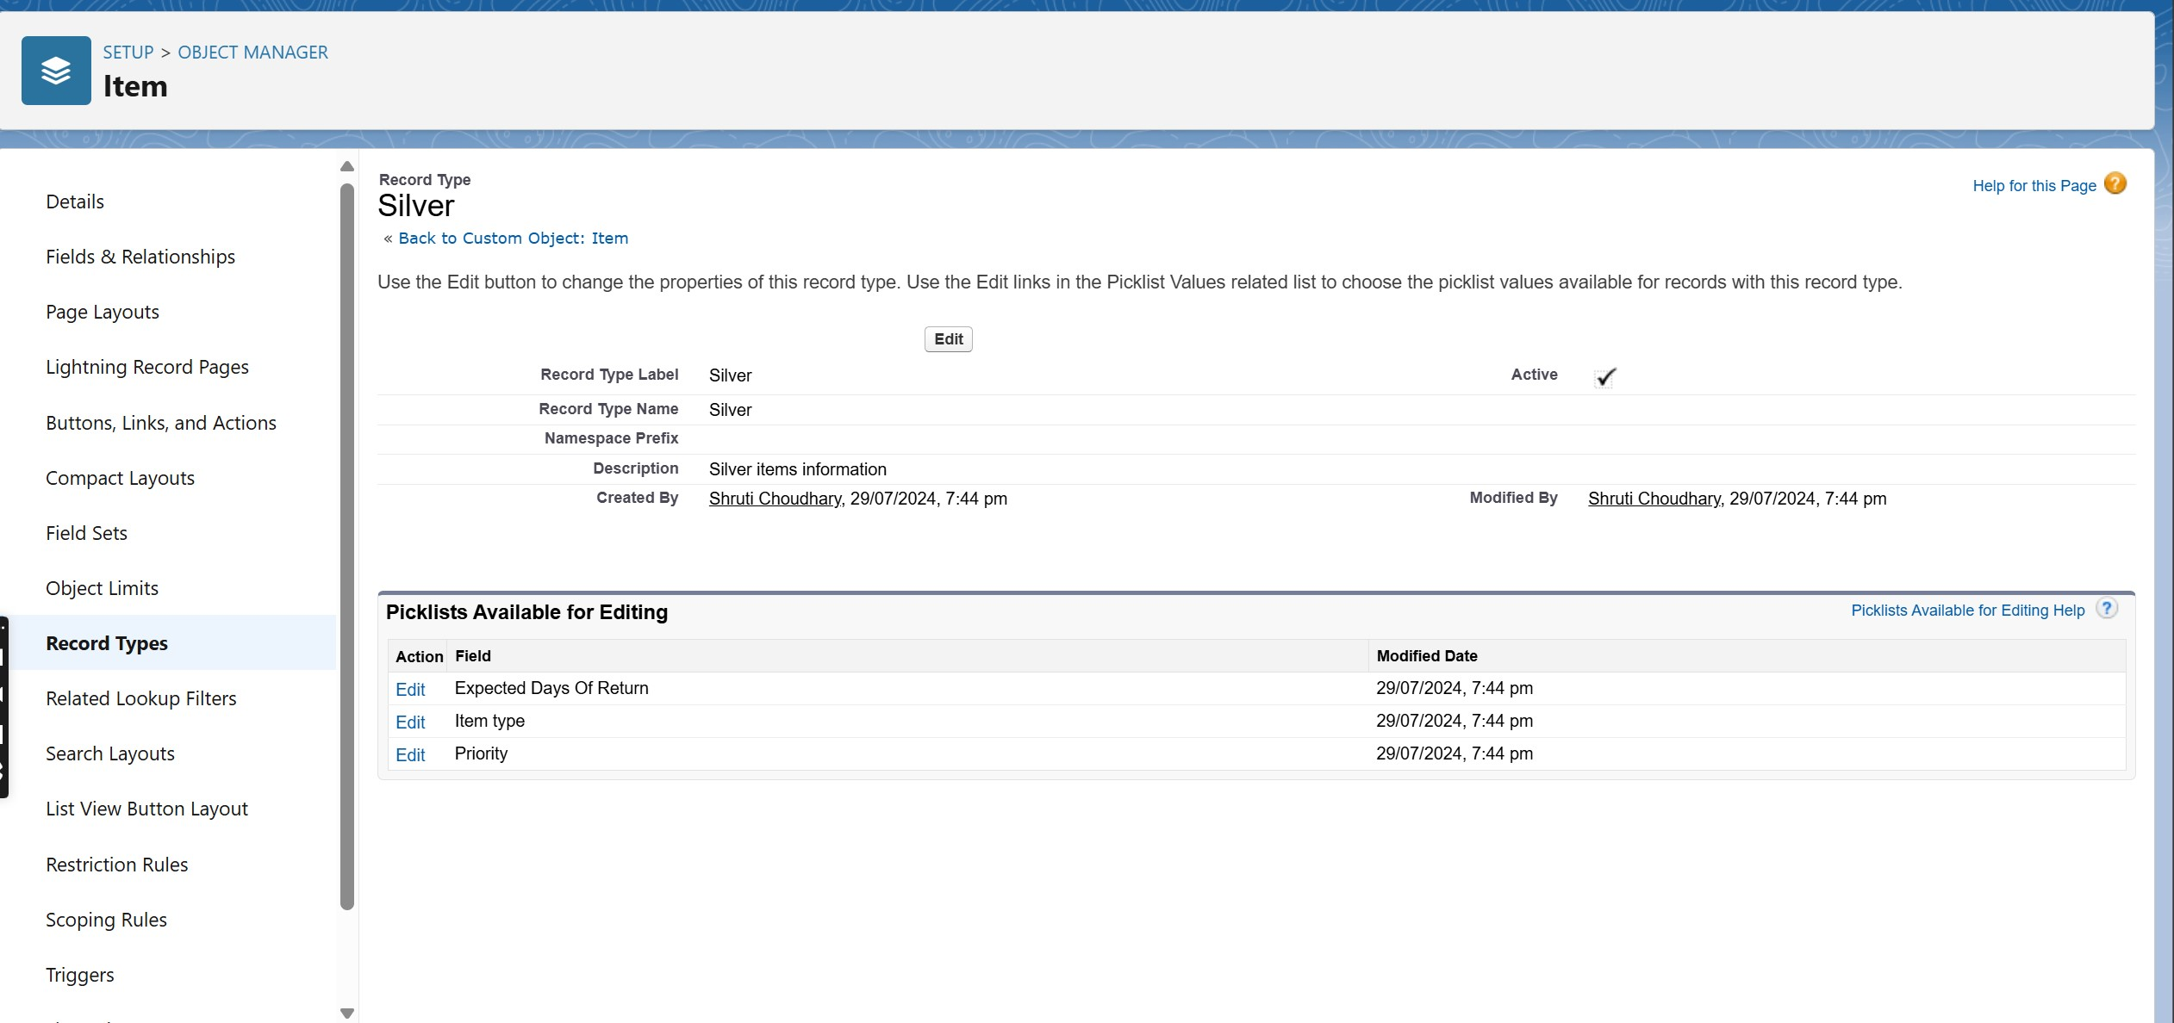

## Task 11. Creating permission set

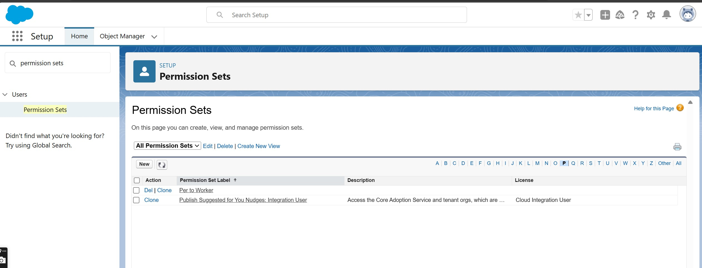

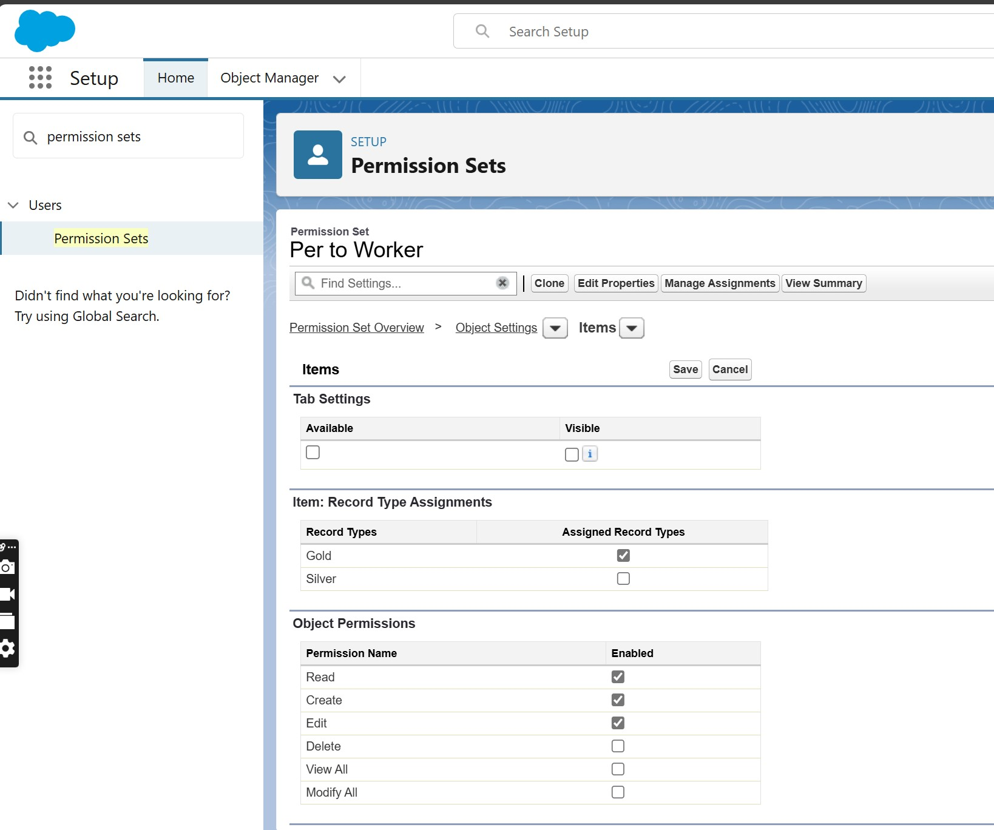

**Task 12. User Adoption**

* **Create a Record (Jewel Customer)**
* **View a Record(Jewel Customer)**

* **Delete a Record(Jewel Customer)**

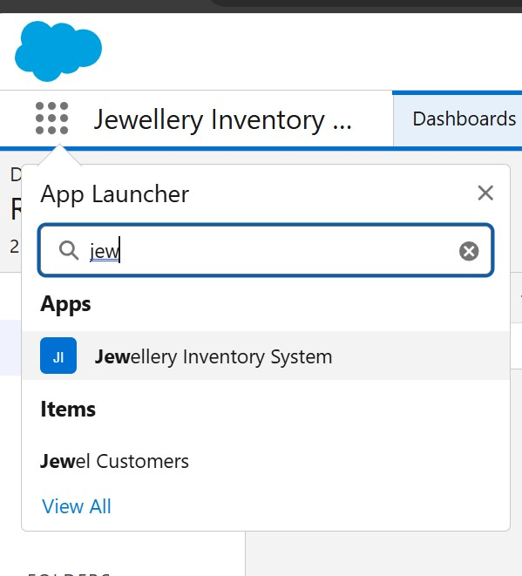 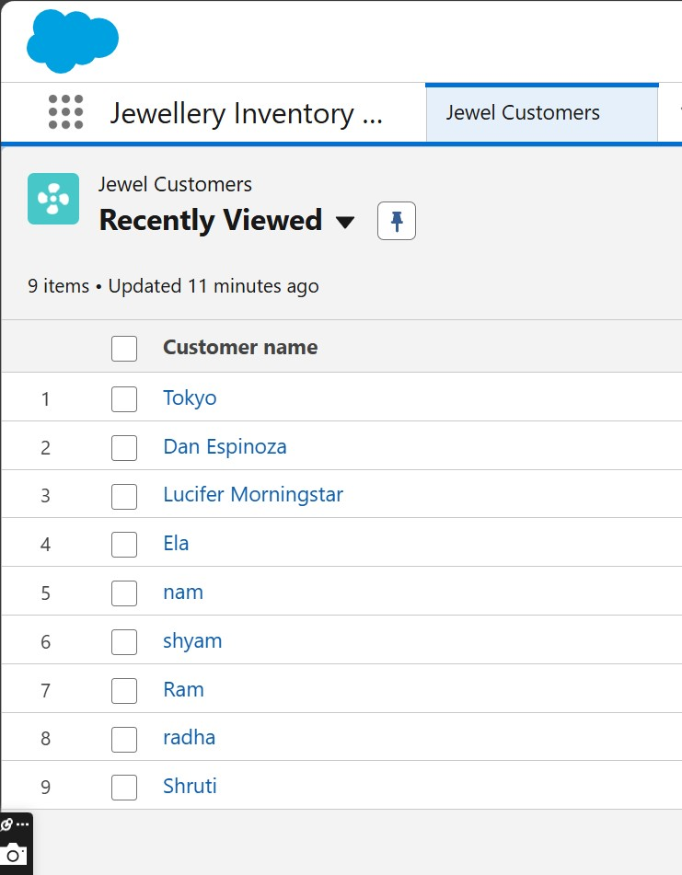

**Task 13. Reports**

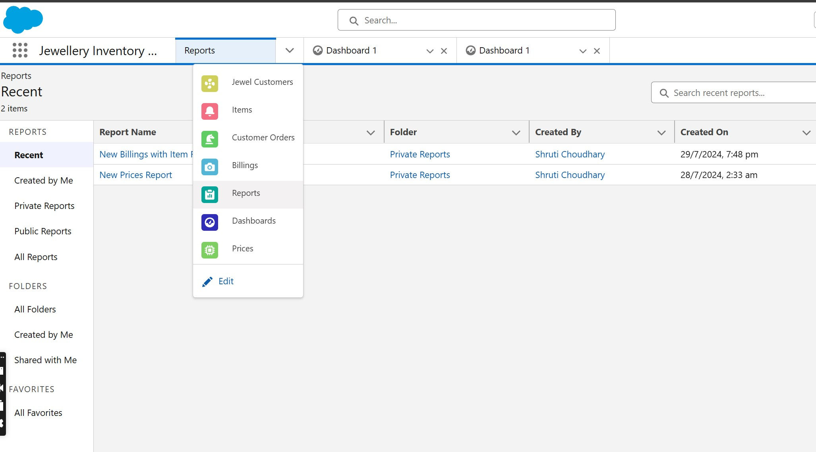

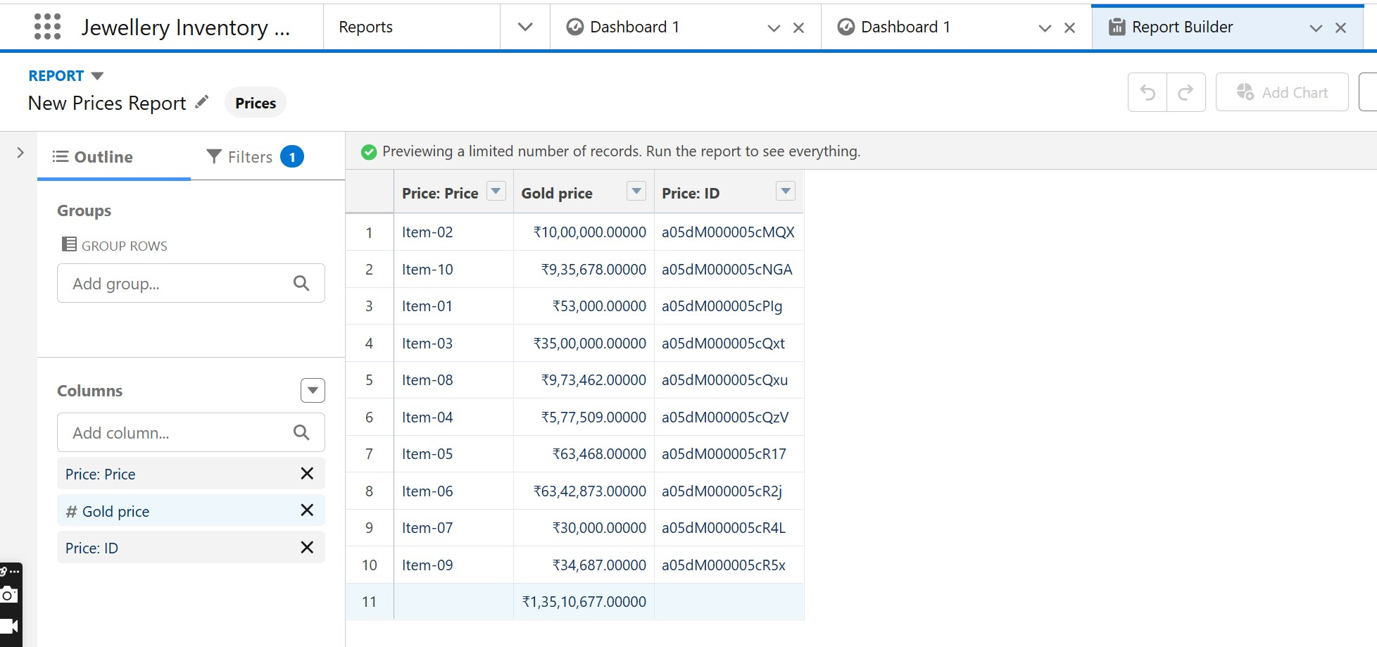

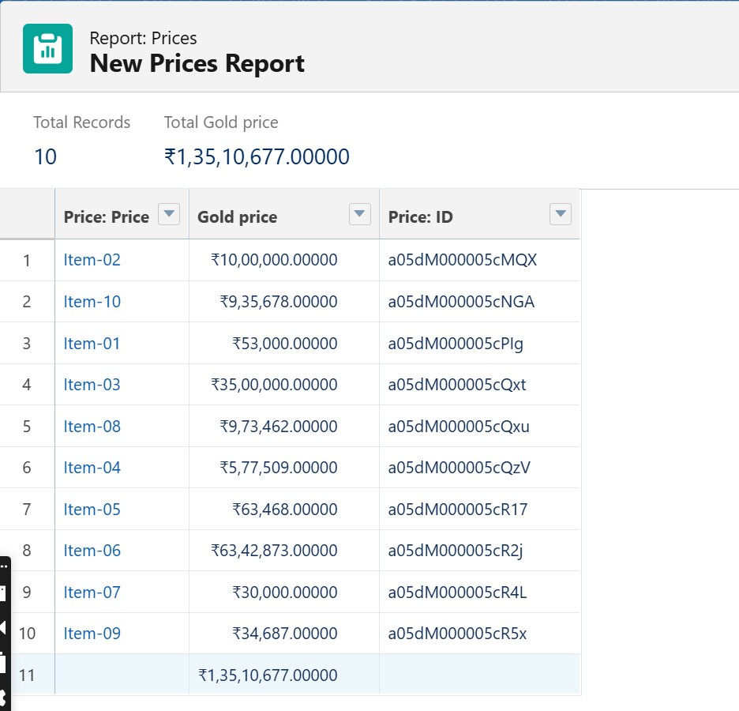

## Task 14. Creating Dashboards

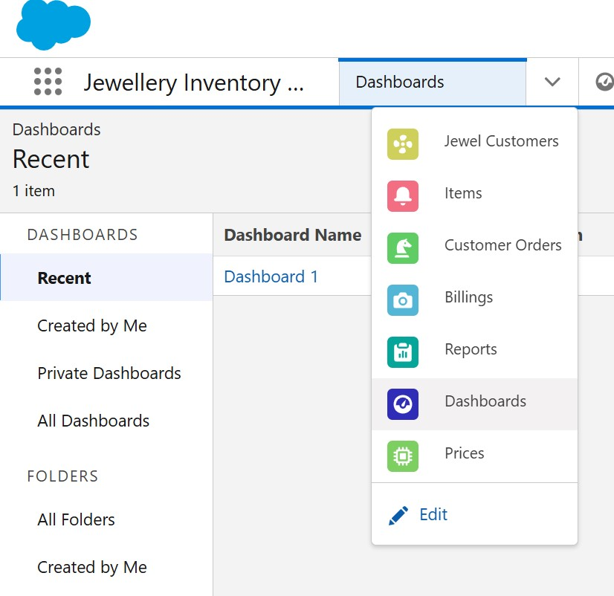

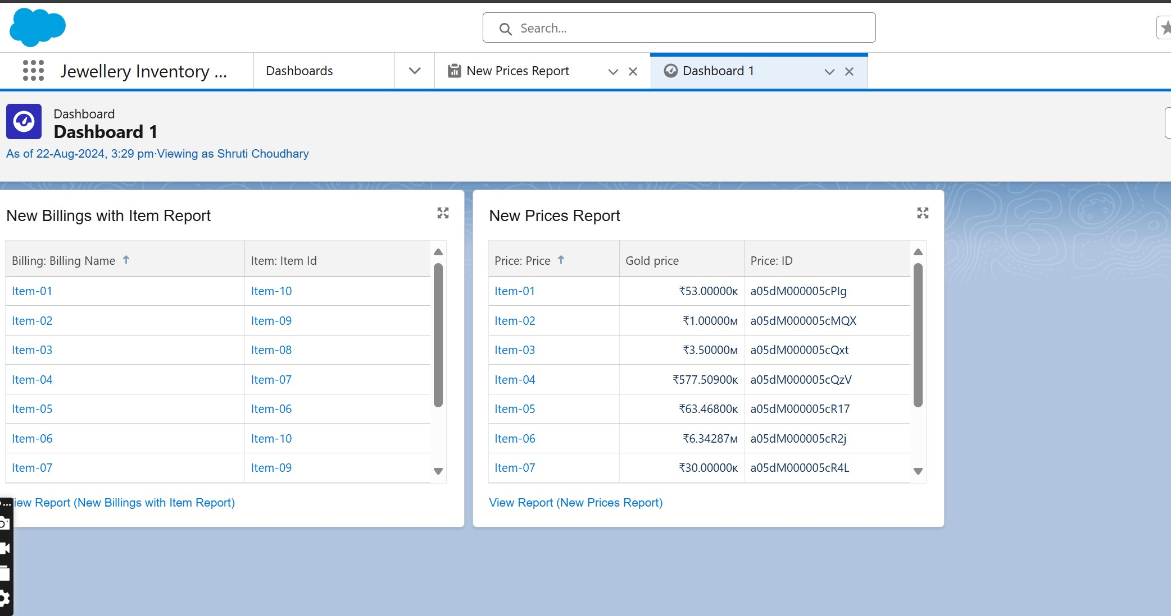

**Task 15. Flows**

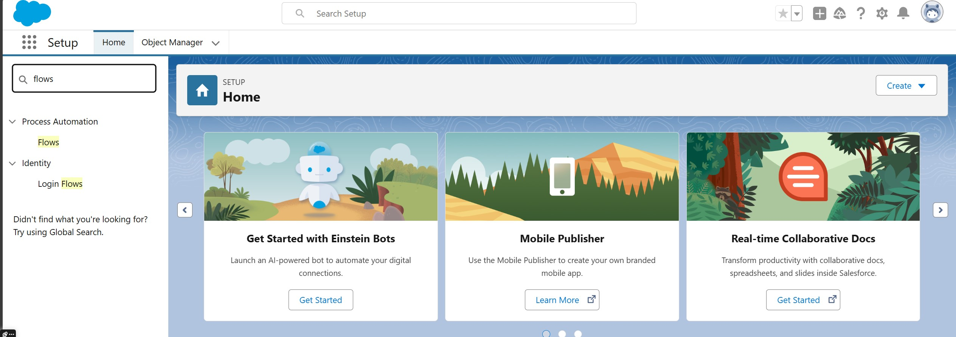

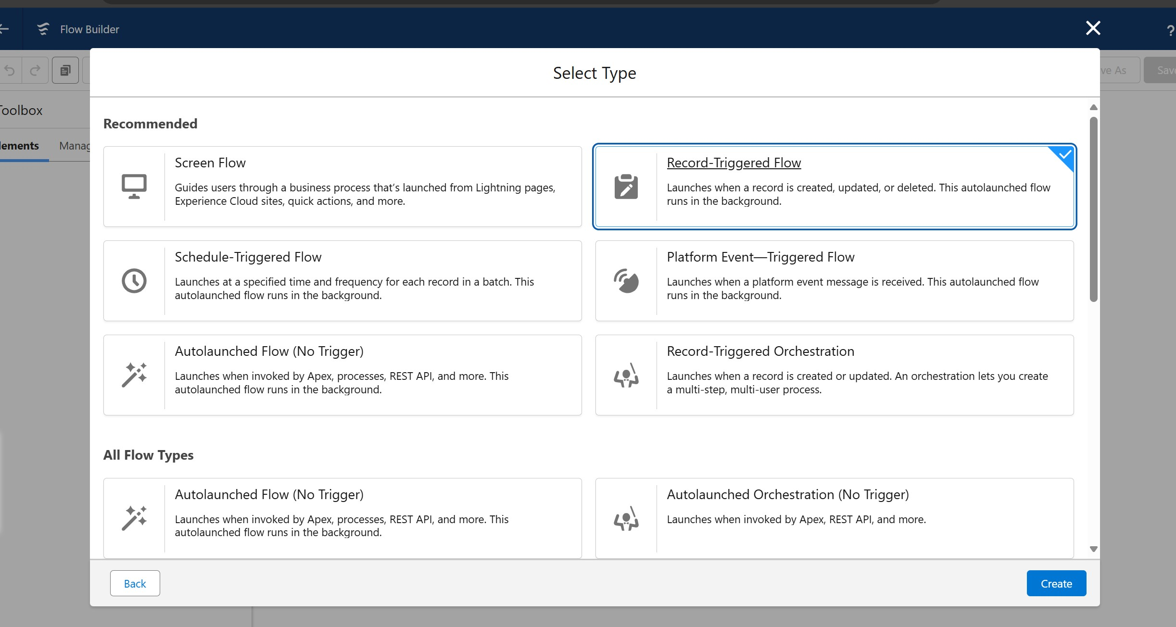

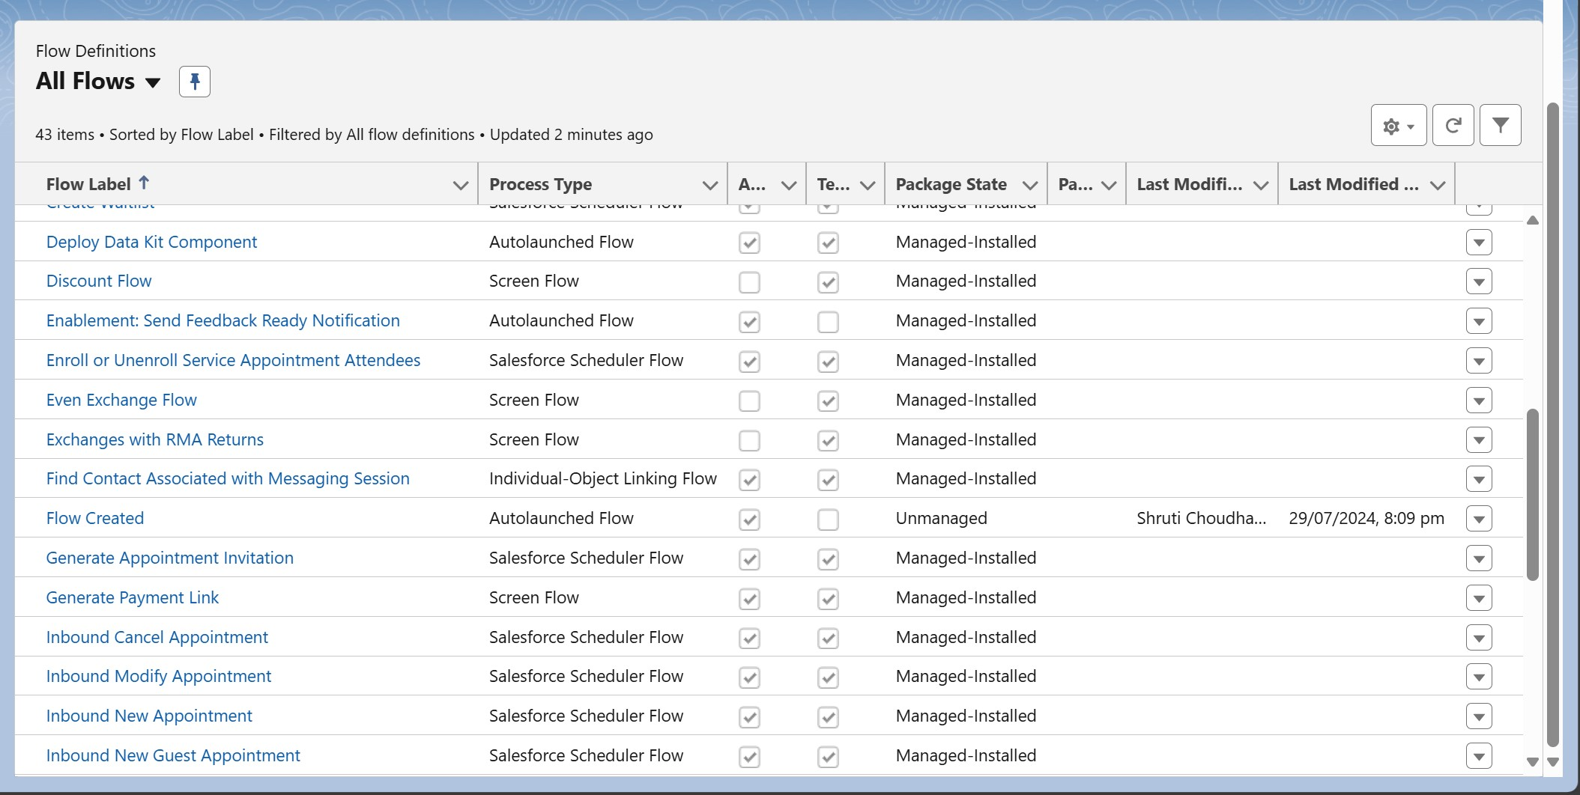

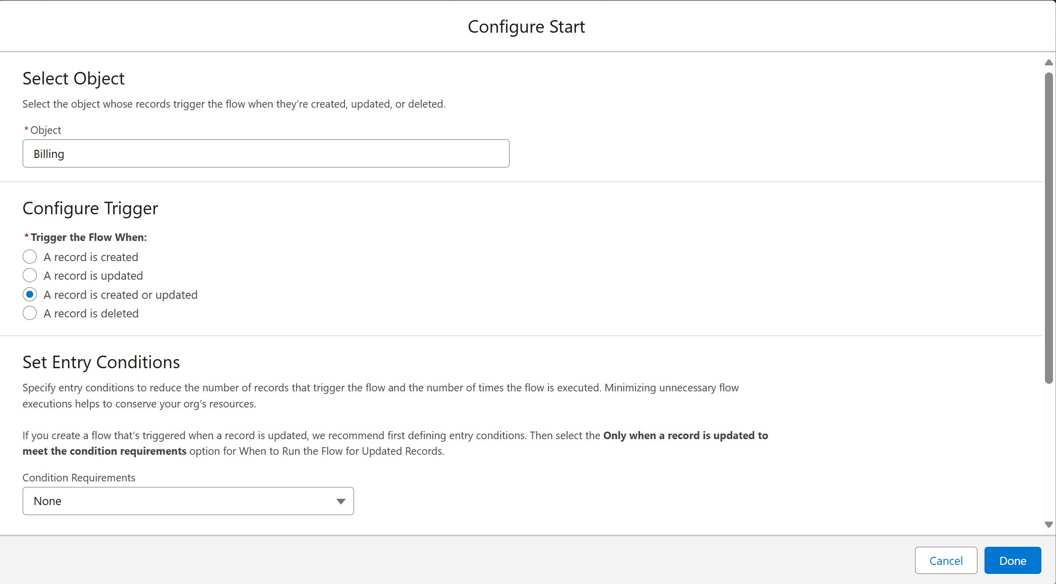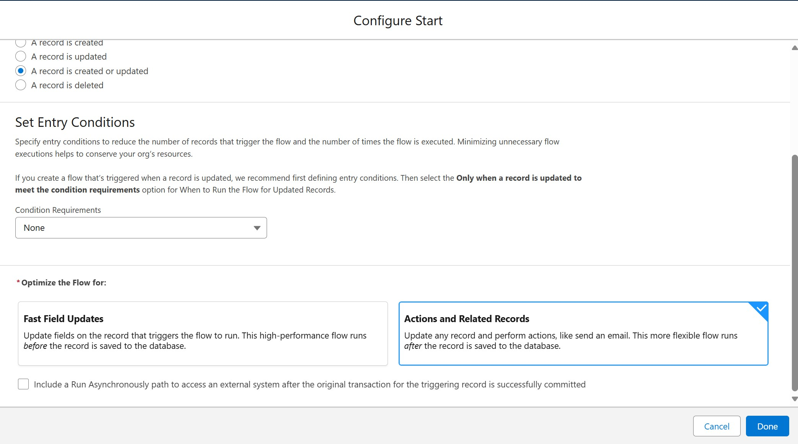

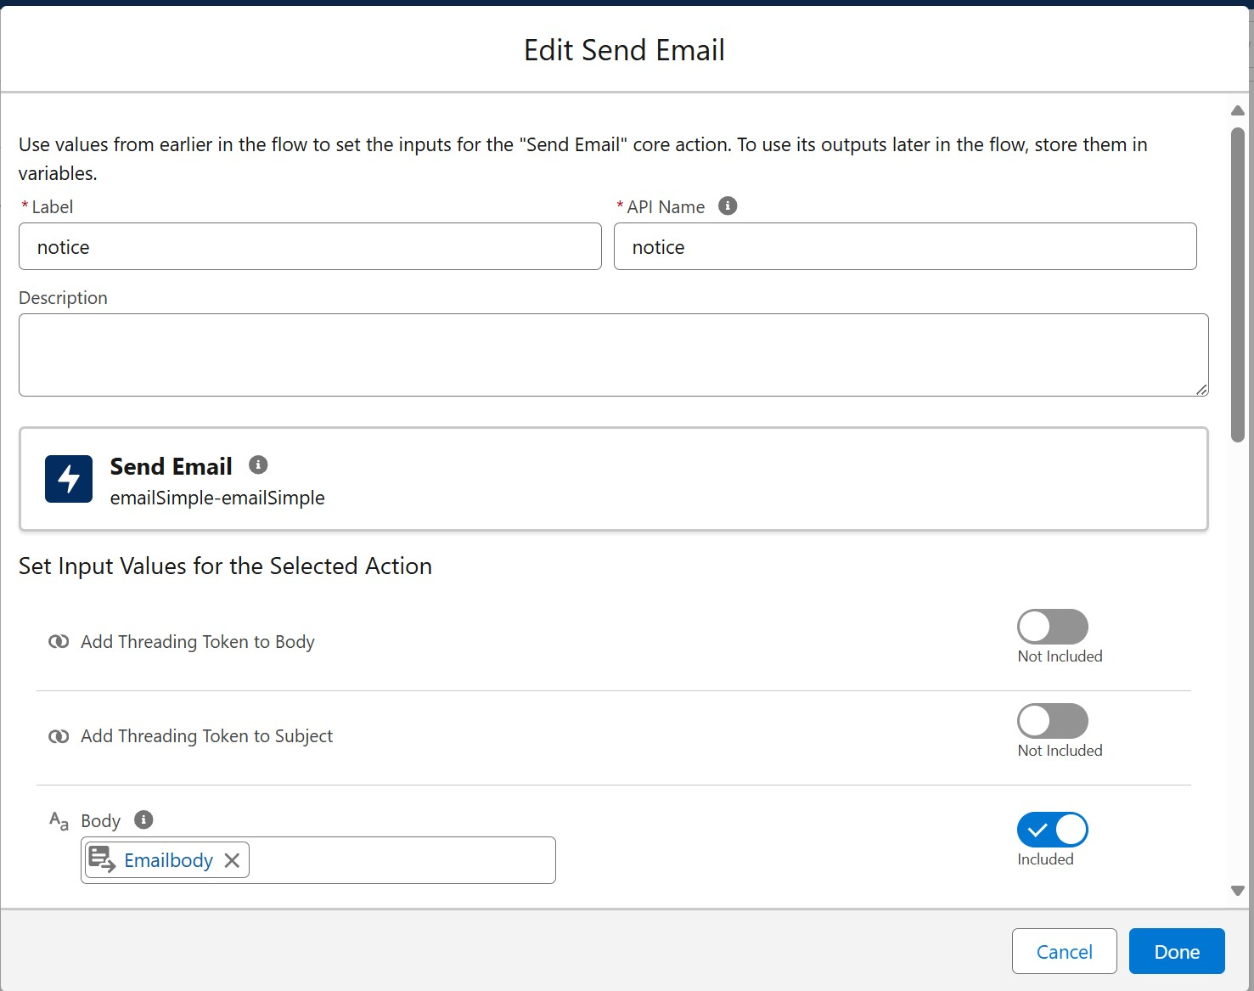

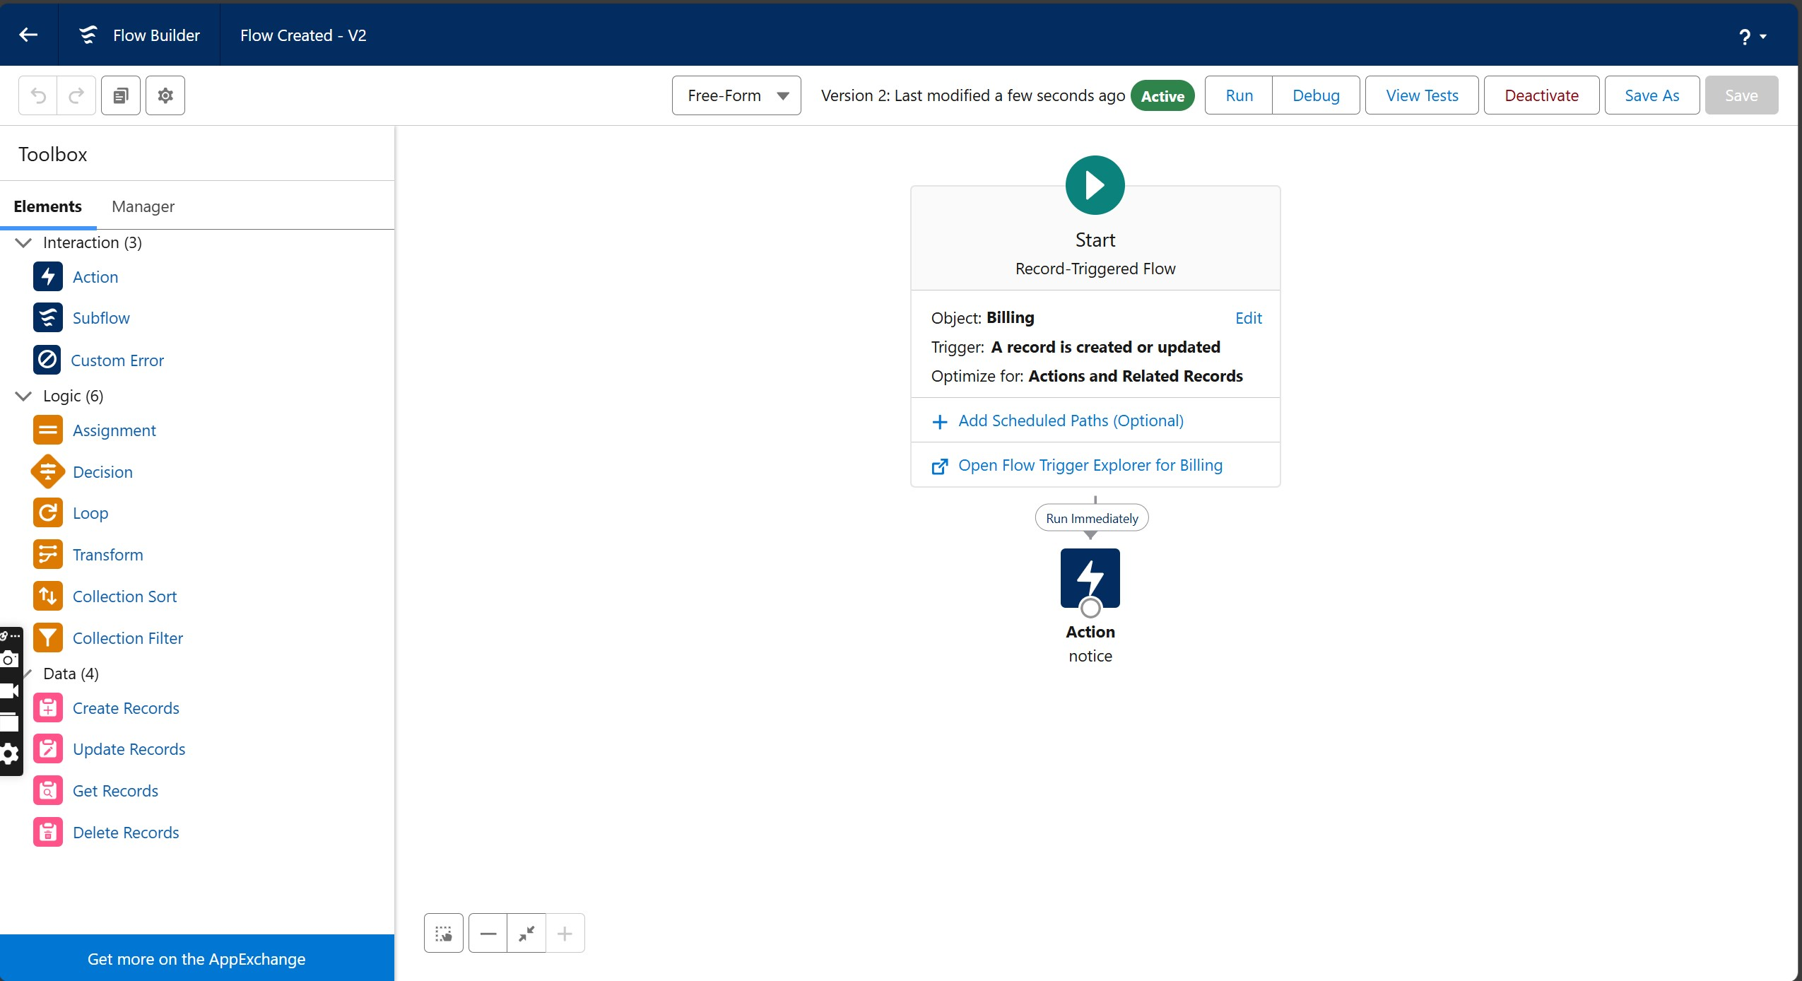

# THANK YOU